Data Analytics Capstone
A Supply Chain Analytics Approach to Price Forecasting for Karnataka's TOP Crops: Reducing Oversupply Risk Through Data-Driven Farm Planning

Final Report
Alvis Lazarus A
Walsh College
QM640: Data Analytics Capstone
Pralhad Teggi
Term 3
August 8, 2026

Project Repository
The raw and cleaned data, the Google Colab analysis notebooks (Interim and Final), and all modelling code for this project are versioned in a public GitHub repository: github.com/learnandgrow072025/capstone_project_alvis. The repository is organized into Data, Program, and Output folders and includes a root-level README.md documenting the repository structure, setup steps, and how to reproduce the full pipeline end to end, so every table, figure, and statistic reported in this document can be regenerated independently rather than taken on faith. Figure 1 in the Materials and Method section shows the repository as it stands.

Table of Contents
Project Repository 2
Abstract 5
Introduction 6
Background and Context 6
Problem Statement 7
Purpose of the Study 8
Research Problems / Research Questions 9
Contributions and Expected Value 10
Literature Review 11
Literature Review Approach 11
Summary of Key Literature 12
Synthesis 14
Distinction From Existing Work 16
Materials and Method 17
Data Sources and Access 17
Inclusion and Exclusion Criteria 19
Data Dictionary 20
Dataset Quality Assessment 23
Data Cleaning 25
Exploratory Data Analysis 30
Insights and Interpretation 35
Research Hypotheses 37
Sample Size and Power Analysis 38
Original Work: Data Splitting, Setup, Access, and Accuracy Measures 40
Architecture Diagram/Workflow 43
System Overview 43
Architecture Diagram 45
Workflow Components 47
Tools and Technologies 49
Results 50
Model Performance 51
Visual Evidence 52
Results by Research Question 56
Overall Interpretation 58
Practical Significance 59
Implementation and User Benefit 59
Deployment Approach 60
System Integration 60
User Interaction 61
Benefits to Users 61
Example Use Case 62
Limitations and Further Improvements 63
Limitations 63
Impact of Limitations 65
Future Improvements 65
Future Scope 66
References 67
Appendix 70
Appendix A: Hyperparameter Search Space (Referenced in Materials and Method) 70
Appendix B: Tomato Cost-of-Cultivation Derivation (Referenced in Materials and Method) 70

Abstract
Onion, tomato, and potato growers in Karnataka-this project's TOP crops-face severe month-to-month price volatility and recurring oversupply cycles; no published tool converts a price forecast into a concrete, farm-level planting or profit decision for this specific crop set and geography. This project addresses that gap with a statistical and machine-learning forecasting pipeline: a pooled XGBoost regression model, hyperparameter-tuned through a nested walk-forward randomized search, benchmarked under rolling-origin validation against a seasonal-naive baseline and a SARIMA baseline, with the resulting forecasts converted into a cost-adjusted profit ranking and into native quantile-regression prediction intervals. The pipeline runs on N = 952 monthly district-crop-month price observations (994 rows including calendar gap months) drawn from four government and research sources-AGMARKNET mandi prices, NASA POWER rainfall, Agricultural Statistics at a Glance yield data, and the DES Cost of Cultivation Scheme, supplemented by a peer-reviewed tomato cost survey-spanning 85 months (July 2019 through July 2026) across four Karnataka districts (Kolar, Chikkaballapur, Bengaluru, and Hassan) and all three crops. The pipeline is implemented in Python (pandas, scikit-learn, XGBoost 2.x, statsmodels) and executed on Google Colab's CPU runtime, since the dataset's size does not require GPU acceleration. On a 28-month held-out test window, the tuned XGBoost model achieved a mean absolute percentage error of 26.57%, versus 39.17% for SARIMA and 50.41% for the seasonal-naive baseline, a statistically significant improvement over both baselines (Wilcoxon signed-rank, p < .001) that held up when the test window was independently varied from roughly 20% to 45% of the panel. RQ3 and RQ4 results are more mixed, and are reported as such: including tomato's real, previously missing cost figure narrowed the profit-ranking advantage found in the interim report to a statistically non-significant difference, and prediction intervals from both XGBoost and SARIMA under-cover their nominal 80% target, though XGBoost's 95% intervals are well calibrated. The intended implementation area is a farmer-facing advisory output delivered through Krishi Vigyan Kendra extension officers, farmer-producer organizations, and Karnataka's Department of Agriculture and Horticulture, to support district-level planting and oversupply decisions with a defensible, uncertainty-aware signal rather than an unqualified point estimate.

Introduction

Background and Context
Onion, tomato, and potato-referred to throughout this report as Karnataka's “TOP crops”-are among the state's most heavily traded and most price-volatile horticultural commodities, moving through the Agricultural Produce Market Committee (APMC) mandi network. Unlike Minimum Support Price (MSP)-backed cereal staples, these three crops are perishable and largely outside MSP protection, which leaves growers fully exposed to short-run supply and demand shocks. A single month of oversupply can erase a season's margin, and no widely available tool currently converts a price forecast into a concrete, farm-level planting decision for these crops in Karnataka specifically.
The modelling approach adopted in this report is grounded directly in the literature reviewed in the next section. Sable et al. (2024) benchmarked fourteen algorithms on five years of Mumbai APMC price data and found extreme gradient boosting (XGBoost) the strongest performer (R² = 0.972), and Dharavath and Khosla (2019) validated seasonal ARIMA specifically on Bengaluru, Karnataka price data. Nayak et al. (2024) went further and forecast these exact three crops, tomato, onion, and potato, using deep learning models trained on the same AGMARKNET and NASA POWER sources this project uses, which is the direct motivation for this report's own literature-grounded model comparison rather than a novelty-driven one; that comparison, and why gradient boosting was chosen over a deep-learning alternative for this project's scope, is detailed in the Literature Review and Materials and Method sections below.
The stakeholders behind this problem are concrete rather than abstract. Smallholder onion, tomato, and potato growers and farmer-producer organizations (FPOs) in the four pilot districts are the primary intended beneficiaries; Krishi Vigyan Kendra (KVK) extension officers are the most plausible delivery channel for a farmer-facing output; and Karnataka's Department of Agriculture and Horticulture and APMC market officials have an operational interest in the same forecasts for regional oversupply and arrival planning. Each of these stakeholder groups reappears in the Contributions and Expected Value subsection below and again in the Implementation and User Benefit section, so the connection between this project's statistical results and who actually uses them is made explicit rather than left implicit.

Problem Statement
Karnataka's TOP-crop growers remain exposed to price volatility and recurring oversupply cycles because no existing, published tool converts a price forecast into an actionable, farm-level planting decision for this specific crop set and geography. Price-forecasting work such as Sable et al. (2024) and Nayak et al. (2024) predicts mandi prices accurately but stops short of a profit figure a farmer could act on. Crop-recommendation work such as Sam and D'Abreo (2025) and Dwibedy et al. (2026) does incorporate economic variables, but at a multi-state or single-market resolution too coarse to reflect Karnataka's district-level mandi and rainfall patterns. No published study forecasts onion, tomato, and potato for Karnataka as a grouped set, benchmarks that forecast against naive and SARIMA baselines under a validation protocol that avoids look-ahead leakage, and converts the result into a profit-ranked, uncertainty-aware recommendation. This is the gap the present project addresses.
Problem statement template: “The objective of this study is to predict Y = the monthly modal (wholesale) mandi price in Rs. per quintal for X = each onion, tomato, and potato district-crop-month combination across four Karnataka districts (Kolar, Chikkaballapur, Bengaluru, and Hassan), using lagged price, monthly rainfall, seasonal indicators, and district-level cost of cultivation as predictors, over July 2019 through July 2026. Success will be evaluated using mean absolute percentage error and root mean squared error relative to seasonal-naive and SARIMA baselines, prediction-interval coverage relative to nominal confidence levels, and realized profit under a cost-adjusted ranking relative to a price-only ranking.”

Purpose of the Study
The purpose of this study is fourfold. First, it predicts monthly wholesale (modal) mandi prices for onion, tomato, and potato across four of Karnataka's major producing districts using a tuned XGBoost regression model, benchmarked against a seasonal-naive baseline and a SARIMA baseline. Second, it explains which agronomic, temporal, and economic features-rainfall, seasonality, lagged price, and cost of cultivation-drive those forecasts, and tests whether Sam and D'Abreo's (2025) finding that economic variables outrank environmental ones replicates in this price-forecasting context. Third, it ranks crop-month combinations by expected profit, combining the price forecast with district-level cost-of-cultivation data for all three crops, rather than stopping at the price forecast alone. Fourth, it quantifies forecast uncertainty through prediction intervals, comparing a parametric (SARIMA) and a non-parametric, quantile-regression (XGBoost) approach, so that any farmer-facing output reports a defensible range instead of a false-precision point estimate.

Research Problems / Research Questions
Research problems must be clearly defined; the four research questions below define the analytical boundaries of the project and are stated once here rather than reworded elsewhere in this report. The statistical technique used to answer each one is presented in the Materials and Method section.

Research Question 1 (RQ1)
To what extent does an XGBoost regression model outperform a naive (seasonal-persistence) baseline and a SARIMA baseline in forecasting monthly modal mandi prices of onion, tomato, and potato across the four pilot districts, as measured by mean absolute percentage error (MAPE) and root mean squared error (RMSE), under rolling-origin (time-respecting) cross-validation?

Research Question 2 (RQ2)
Among lagged price, monthly rainfall, seasonal/calendar indicators, and district-level cost of cultivation, which features contribute most to the XGBoost model's price predictions, and does the resulting importance ranking replicate Sam and D'Abreo's (2025) finding that economic variables outrank environmental ones?

Research Question 3 (RQ3)
Does a profit-ranking model that combines XGBoost price forecasts with cost-of-cultivation data identify crop-month combinations with significantly higher expected returns than a price-only ranking?

Research Question 4 (RQ4)
Do prediction intervals generated from the XGBoost forecast via a native quantile-regression objective achieve empirical coverage closer to nominal confidence levels (80% and 95%) than intervals derived from the SARIMA baseline?

Contributions and Expected Value
This project's contribution is best stated against the three specific gaps identified above, rather than as a general claim of novelty. Tran et al.'s (2023) systematic review of 27 papers found that no reviewed study groups related commodities into one pipeline; this project forecasts onion, tomato, and potato as one grouped, profit-aware pipeline. Sable et al. (2024) and Nayak et al. (2024) forecast price accurately but stop at the forecast; this project converts that forecast into a profit figure (RQ3) and a calibration-checked uncertainty range (RQ4). Sam and D'Abreo (2025) and Dwibedy et al. (2026) incorporate economic variables into crop guidance at a multi-state or single-market resolution; this project operates at Karnataka's district level using district-specific rainfall and market prices and separately reports forecast accuracy, which neither prior study does.
- Practical contribution: a reproducible, three-crop, four-district pipeline that converts a raw mandi price feed into a profit-ranked, uncertainty-quantified planting signal, rather than a price forecast a farmer still has to interpret unaided.
- Technical contribution (methods/models): a pooled, sample-size-justified XGBoost model with an executed nested walk-forward hyperparameter search, benchmarked against both a naive and a SARIMA baseline under rolling-origin validation, with prediction-interval calibration checked against both a parametric and a non-parametric method and robustness checked across three independently sized test windows-a combination not found together in any single study reviewed in Section 2.
- Value to stakeholders/target users: smallholder onion, tomato, and potato growers and farmer-producer organizations (FPOs) in the four pilot districts gain a defensible price and profit signal; Krishi Vigyan Kendra (KVK) extension officers gain a concrete tool to deliver that signal; and Karnataka's Department of Agriculture and Horticulture and APMC market officials gain a district-level input for regional oversupply and arrival planning. The Implementation and User Benefit section develops each of these into a concrete deployment and use-case description.

Literature Review

Literature Review Approach
Sources were located through keyword searches ("agricultural price forecasting," "crop recommendation machine learning," "XGBoost price prediction," "deep learning agricultural commodity," "large language model (LLM) agricultural advisory") across Scientific Reports, PLoS ONE, arXiv, IEEE Xplore, and general web search, then filtered against three criteria: the source must forecast a price or recommend a crop using a quantitative or machine-learning (ML) method, report enough detail to compare against this project's design, and trace to a verifiable primary source. Thirteen sources meet these criteria and are organized below by relevance to the four research questions; four statistical-method references (Cohen, 1988; Diebold & Mariano, 1995; Green, 1991; Shapiro & Wilk, 1965) are cited directly in Materials and Method where each technique is applied, rather than repeated in the relevance matrix, since they are methodological rather than domain citations.

Summary of Key Literature
For each source, Table 1 records its purpose/context, method, findings, and relevance to this project's research questions and modelling decisions; the synthesis paragraphs that follow are organized by theme rather than repeating the table row by row.
Table 1
Literature Relevance Matrix
Author (Year) | Domain/Context | Dataset/Setting | Method(s) | Key Findings | How It Supports RQ(s)/Project Decisions
Sable et al. (2024) | Agricultural price forecasting, Mumbai | 5 years of Mumbai APMC price data, 14 algorithms compared | XGBoost, Random Forest, SVR, ARIMA, and 10 other algorithms | XGBoost strongest fit (R² = .972); flagged their own earlier validation as leaky | RQ1: primary justification for choosing XGBoost as this project's model; RQ1: motivates rolling-origin validation
Dharavath & Khosla (2019) | Seasonal price forecasting, Karnataka fruit/vegetable markets | Bengaluru, Karnataka wholesale price series | Seasonal ARIMA (SARIMA) | SARIMA is a credible, literature-grounded baseline specifically for Karnataka produce prices | RQ1: justifies SARIMA (not a generic alternative) as the classical baseline
Nayak et al. (2024) | Deep learning price forecasting, TOP crops, India | Weekly tomato/onion/potato prices, 2002-2023, AGMARKNET + NASA POWER weather | NBEATSX, TransformerX (deep learning, exogenous-variable architectures) | NBEATSX (RMSE 110.33) outperformed classical/ML baselines by incorporating rainfall and temperature | RQ1/RQ2: same crops and data sources as this project; supports including rainfall as a predictor and is the direct deep-learning comparator discussed in Materials and Method
Manogna et al. (2025) | Deep learning price forecasting, 23 Indian commodities | Daily wholesale prices, 2010-2024, 165 markets, incl. onion/tomato | LSTM, GRU, RNN vs. ARIMA, SVR, XGBoost | GRU/LSTM substantially outperformed ARIMA (e.g., onion MAPE 14.6% vs. 92.7%) | RQ1: further deep-learning evidence weighed against this project's ten-week-scope decision to use XGBoost rather than a neural model
Paul et al. (2022) | Agricultural price forecasting, Odisha | Brinjal wholesale prices | Machine learning ensemble methods | Gradient boosting is a strong, field-typical choice for tabular price forecasting | RQ1: corroborates gradient boosting as the field default this project follows
Tran et al. (2023) | Systematic review, agricultural commodity price forecasting with ML | 27 screened papers, India the most-studied country | Systematic literature review | No reviewed study groups related commodities into one forecasting pipeline | RQ1-RQ4: names the specific gap this project's grouped, three-crop pipeline closes
Sam & D'Abreo (2025) | Crop recommendation, environmental + economic factors | Multi-state Indian crop dataset | Machine learning crop recommendation model | Economic variables outrank environmental variables in their recommendation model | RQ2: direct replication target for the permutation-importance ranking
Dwibedy et al. (2026) | Profit-aware crop advisory, "Kisan AI" | Crop advisory system design (India) | Advisory system incorporating price signals | Coined "economic blindness" for advisory tools that ignore price | RQ3/Implementation: motivates converting a price forecast into a profit-ranked recommendation, not just a price number
Doshi et al. (2018) | Crop recommendation, "AgroConsultant" | Soil/climate features, India | Machine learning classification algorithms | Solid agronomic-suitability classifier | Literature gap: agronomic-fit systems that omit price, motivating this project's price/profit focus
Mancer et al. (2025) | Crop classification, comparative ML study | Soil and climate features (pH, N/P/K, weather) | Bagging classifier vs. other ML models | Bagging classifier achieved 99.77% accuracy for crop classification | Literature gap: agronomic fit without economic signal
Senapaty et al. (2024) | Crop recommendation decision support | Agronomic/soil dataset | Machine learning classification algorithms | Decision-support framing for crop choice, agronomic criteria only | Literature gap: same theme, reinforces the RQ3 profit-ranking contribution
Sawant et al. (2026) | LLM-based agricultural advisory, retrieval-augmented generation | Standardized crop-practice documents, farmer queries | RAG combined with four LLMs (Llama3.1, Mistral, Phi3, Qwen2.5) | Mistral and Qwen2.5 achieved the strongest relevance, semantic quality, and efficiency for farmer-facing advisory | Implementation and User Benefit: representative agentic/LLM delivery mechanism considered for surfacing this project's forecasts to farmers
Vanitha et al. (2018) | Tomato cost-of-cultivation economics, Kolar district | 150-grower survey, 3 taluks x 3 seasons | Farm-economics survey, cost-of-cultivation accounting | Published a full taluk x season cost-of-cultivation breakdown for tomato | RQ3/Materials and Method: primary source for the tomato cost figure that resolves the interim report's RQ3 data gap

Synthesis
Three threads converge on the same open problem. First, the price-forecasting literature has moved from classical statistical models (Dharavath & Khosla, 2019) through gradient boosting (Sable et al., 2024; Paul et al., 2022) to deep learning (Nayak et al., 2024; Manogna et al., 2025); gradient boosting-specifically XGBoost-remains repeatedly the strongest or most practical fit for a panel this size, which is why it is the primary model used here (the deep-learning trade-off is discussed in the next paragraph). Second, the crop-recommendation literature (Sam & D'Abreo, 2025; Dwibedy et al., 2026; Doshi et al., 2018; Mancer et al., 2025; Senapaty et al., 2024) shows economic variables matter for guidance systems, but most such systems either omit price entirely or fold it in without separately reporting forecast accuracy, and none operates at Karnataka's district level. Third, and most directly, Tran et al.'s (2023) systematic review of 27 papers found that not one groups related commodities into a single pipeline; framing onion, tomato, and potato as one grouped, profit-aware pipeline for Karnataka closes that specific, named gap. Three of the sources behind this gap framing — Sam and D'Abreo (2025), Dwibedy et al. (2026), and Tran et al. (2023) — are arXiv preprints rather than peer-reviewed publications at the time of writing; the gap they identify is corroborated across three independent sources rather than resting on one, but that preprint status is disclosed here rather than left implicit.
Deep learning and agentic/LLM trends. Two recent studies forecast these same or closely related crops with deep learning rather than gradient boosting. Nayak et al. (2024) used exogenous-variable architectures (NBEATSX, TransformerX) on weekly tomato, onion, and potato prices from the same AGMARKNET and NASA POWER sources this project uses, and found weather variables materially improved accuracy-independent support for this project's own decision to include rainfall as an RQ2 predictor. Manogna et al. (2025) found Long Short-Term Memory (LSTM), Gated Recurrent Unit (GRU), and Recurrent Neural Network (RNN) models substantially outperformed ARIMA, though closer to XGBoost, across 23 Indian commodities including onion and tomato. Both are read here as evidence that a deep-learning extension is a credible next step, not a reason to have used one for this project: their architectures are trained on larger panels than the roughly 900-1,000-row pooled panel available here, and neural models typically need more data than that to avoid overfitting. On the delivery side, Sawant et al. (2026) demonstrated a retrieval-augmented-generation framework pairing large language models with agricultural practice documents to answer farmer queries in natural language, finding Mistral and Qwen2.5 the strongest performers; this is the specific agentic/LLM precedent considered in Implementation and User Benefit as a channel for surfacing this project's outputs to a non-technical audience, rather than a technique adopted inside the forecasting pipeline itself.
A second, methodological thread shapes the validation protocol used throughout this report: both Sable et al. (2024) and Sam and D'Abreo (2025) independently reported an information-leakage problem in their own initial validation setup-a suspiciously perfect R² in one case, random-shuffle cross-validation in the other-and had to correct for it. Every walk-forward split used in this report is built specifically to avoid that failure mode, so that training data always precedes the test month it predicts and is never mixed randomly with it.

Distinction From Existing Work
Table 1 shows what each prior study did; stated plainly, none did the following together, and this project does: (a) convert a price forecast into a profit figure, unlike Sable et al. (2024) and Nayak et al. (2024), who stop at the forecast; (b) operate at Karnataka's district level with separately reported forecast accuracy, unlike the multi-state or single-market resolution of Sam and D'Abreo (2025) and Dwibedy et al. (2026); (c) group onion, tomato, and potato into one pipeline, the gap Tran et al. (2023) named across 27 screened papers; and (d) benchmark against both a naive and a SARIMA baseline under rolling-origin validation, execute and report an actual hyperparameter search, and quantify prediction-interval coverage across a parametric and a non-parametric method over multiple test-window sizes. This combination in one pipeline, on one four-district panel, is this report's compound contribution.

Materials and Method
This section describes the data used, how it was assessed and cleaned, the exploratory analysis that grounds the modelling choices in the Architecture diagram/Workflow section, the study's formal hypotheses and sample-size justification, and the original experimental work-data splitting, database setup, data access, and training-versus-test accuracy measures-behind every result reported in the Results section.

Data Sources and Access
Five sources feed this project: four government/research data extracts, read directly from their raw files, and one peer-reviewed survey used to derive a single tomato cost figure (below). The fourth government extract is drawn from the Directorate of Economics and Statistics (DES) Cost of Cultivation Scheme. Nothing in this report is manually re-typed from a source table; every number is produced by the analysis notebook reading these sources directly.
Table 2
Raw Data Sources Used in This Project
Source | Coverage | URL
AGMARKNET (Market-wise Report) | Daily market/commodity wholesale prices, 2019-2026, Karnataka | agmarknet.gov.in/marketwisespecificcommodityinput
NASA POWER | Daily district-level rainfall, 2016-2026, Karnataka districts | power.larc.nasa.gov
Agricultural Statistics at a Glance 2023 | Annual district-level area, production, and yield | desagri.gov.in (Agricultural Statistics at a Glance 2023)
DES Cost of Cultivation Scheme | Annual state-level cultivation cost per hectare (onion, potato) | desagri.gov.in (Cost of Cultivation Scheme)
Vanitha et al. (2018) survey | 150-grower, 3-taluk x 3-season tomato cost-of-cultivation survey, Kolar district | International Journal of Agriculture Sciences, 10(16)
Tomato's cost of cultivation is not part of the DES series, which covers onion and potato only. The interim report identified Vanitha et al.'s (2018) Kolar-district survey as the intended source but could not merge it in, since the survey does not publish a single per-hectare figure in the DES format. That gap is closed here: Vanitha et al.'s Table 6 reports total cost of cultivation (Rs./acre) for three Kolar-district taluks across three growing seasons, nine figures in total. Their unweighted mean, Rs. 1,56,269.22/acre, converted to hectares (1 ha = 2.4710538 acres), gives a constant tomato cost of Rs. 3,86,149.66/hectare, applied to every tomato row the same way the DES-derived onion and potato figures are. Two limitations are carried forward explicitly: the survey is from the non-inflation-adjusted 2015-16 season, which likely understates tomato's current cost and so biases RQ3's tomato profit estimate conservatively; and it is a Kolar-district figure applied statewide, the same compromise already made for onion and potato. With this figure in place, tomato is included in RQ3 for the first time, resolving the interim report's data gap (derivation code in Appendix B).
The raw and cleaned data, the Google Colab analysis notebooks, and all modelling code are versioned in the public GitHub repository named on the page following the title page, organized into Data, Program, and Output folders with a root-level README documenting setup and reproduction steps. Figure 1 shows the repository as it stands.
Figure 1
capstone_project_alvis repository on GitHub (public), showing the Data, Output, and Program folders, commit history, and README.
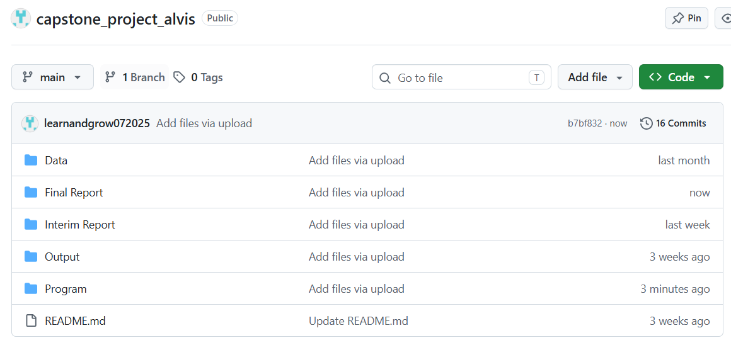

District Selection
Kolar and Chikkaballapur (the tomato and onion belt, and the site of the Vanitha et al. (2018) survey), Bengaluru, and Hassan (historically Karnataka's largest potato district) were chosen over a full statewide sweep to keep data cleaning tractable within a ten-week project, since cleaning effort scales with the number of districts included. Four markets with confirmed reporting coverage across all three crops represent a more tractable and honest scope than a sixteen-district plan with unverified coverage.

Inclusion and Exclusion Criteria
Included: onion, tomato, and potato price, rainfall, yield, and cost-of-cultivation records for Kolar, Chikkaballapur, Bengaluru, and Hassan, July 2019 through July 2026. Excluded, with reasons stated: rows failing internal price consistency (modal price outside its own min/max range) are dropped as data-entry errors; arrival quantity is excluded as a feature since it is partly a consequence of price (target-leakage risk); minimum and maximum price are excluded as near-duplicates of the modal-price target; Minimum Support Price does not apply, since none of the three crops are MSP-notified; and a Hassan potato "regime-break" dummy marking the district's roughly 2006-2007 acreage collapse (Deccan Herald, 2026) was considered but excluded, since the panel begins after that collapse and the dummy would be constant across the sample. Statistical outliers on price (Table 9) are flagged, not excluded, since events such as onion's 2019-2020 supply-shock spike are real volatility this project forecasts, not noise.

Data Dictionary
Tables 3 through 7 present the dictionary for each source in turn-mandi price, rainfall, yield and area, cost of cultivation, and engineered variables-so that every predictor used anywhere in this report, raw or derived, has a matching entry, satisfying the reproducibility expectation this criterion targets directly.
Table 3
Data Dictionary: Mandi (Wholesale) Price, Market-wise Report
Variable | Type | Unit | Meaning | Relevance
Date | Date | Daily (YYYY-MM-DD in source) | Calendar date of the reported wholesale transaction | Aggregated to monthly modal price; the time axis for RQ1's forecast
State | Categorical | - | State name (Karnataka throughout this extract) | Confirms geographic scope; constant, not a model feature
District/Market | Categorical | 73 APMC markets in source | APMC market/yard name (e.g., “Bengaluru APMC”, “Hassan APMC”); source column is literally named “district/market” | Filtered to the markets covering the four pilot districts (Kolar, Chikkaballapur, Bengaluru, Hassan)
Commodity | Categorical (3 levels) | - | Crop type: Onion, Tomato, or Potato | Defines the three parallel forecasting problems
Variety | Categorical (17 levels in source) | - | Sub-type/grade reported at that market (e.g., Local, Potato, Other) | Not currently used as a model feature; retained for a possible future stratification check
Modal Price | Continuous | Rs./quintal | Most frequently traded wholesale price for that date/market/commodity | Primary dependent variable for RQ1 (aggregated to a monthly series)
Min Price / Max Price | Continuous | Rs./quintal | Reported low/high wholesale price for the same observation | Supports volatility/range checks; not a primary predictor
Arrival Quantity | Continuous | Metric tonnes | Quantity of the commodity arriving at the market that day | Not in the current RQ2 predictor set; flagged as a candidate supply-side feature for later iterations
Table 4
Data Dictionary: Rainfall, NASA POWER District Extract
Variable | Type | Unit | Meaning | Relevance
date | Date | Daily (YYYY-MM-DD) | Calendar date of the rainfall reading | Aggregated to a monthly total before merging onto the price panel
district | Categorical (16 districts in source) | - | Karnataka district name | Join key onto the price panel's district field
grid_lat / grid_lon | Continuous | Decimal degrees | Latitude/longitude of the single NASA POWER grid cell used to represent that district | Traceability of the rainfall figure to its source grid cell; not a model feature itself
precipitation_mm | Continuous | mm/day | Daily rainfall total at the district's grid cell | Environmental predictor for RQ2 (aggregated to monthly mm)
Table 5
Data Dictionary: Yield, Area, and Production, Agricultural Statistics at a Glance 2023
Variable | Type | Unit | Meaning | Relevance
Year | Categorical/ordinal | Agricultural year (e.g., “2021 - 2022”) | Cropping year the figures refer to | Annual grain; mapped onto the monthly panel as a constant-within-year covariate
District | Categorical (33 values incl. state total) | - | Karnataka district (source also includes an “All Districts” state-level row) | Join key onto the price panel's district field
crop | Categorical (3 levels) | - | Onion, Tomato, or Potato | Join key onto the price panel's commodity field
area_hectares | Continuous | Hectares | District-level area under cultivation for that crop-year | Context for the yield figure used in the profit calculation
production_tonnes | Continuous | Tonnes | District-level total production for that crop-year | Cross-check for yield (production ÷ area)
yield_tonnes_per_hectare | Continuous | Tonnes/hectare | District-level average yield for that crop-year | Yield multiplier in the RQ3 profit formula (forecast price × yield − cost)
Table 6
Data Dictionary: Cost of Cultivation, DES Cost of Cultivation Scheme + Vanitha et al. (2018)
Variable | Type | Unit | Meaning | Relevance
year | Categorical/ordinal | Fiscal year (e.g., “2021-2022”) | Year the cost figures refer to | Annual grain; mapped onto the monthly panel as a constant-within-year covariate
state | Categorical | - | “Karnataka” or “All-India” - state-level only in the confirmed extract, no district field | See state-vs-district note below; limits RQ3's stated district-level cost precision
crop | Categorical (2 levels in source) | - | Onion or Potato only; the DES series does not cover tomato | DES covers onion and potato only; tomato's cost is supplied by the Vanitha et al. (2018) derivation (see Data Sources and Access and Appendix B), so all three crops enter the RQ3 profit ranking.
operational_cost_rs_per_ha | Continuous | Rs./hectare | Variable input costs (seed, labor, fertilizer, irrigation, etc.) | Component of total cultivation cost
fixed_cost_rs_per_ha | Continuous | Rs./hectare | Fixed costs (land rent/value, depreciation, etc.) | Component of total cultivation cost
total_cost_rs_per_ha | Continuous (derived: operational + fixed) | Rs./hectare | Total per-hectare cultivation cost | Cost term in the RQ3 profit formula
Table 7
Data Dictionary: Derived Variables (Engineered, Not Raw Source Columns)
Variable | Type | Unit | Meaning | Relevance
lag1_price | Continuous | Rs./quintal | Previous month's modal price for the same crop-district series | Engineered predictor for RQ1, RQ2, RQ4
season | Categorical (3 levels) | - | Kharif / Rabi / Summer, derived from calendar month | Engineered predictor for RQ1, RQ2, RQ4

Dataset Quality Assessment
Each raw source was assessed on its own terms for completeness, internal consistency, likely bias, and its missing-value pattern before any cleaning action was taken, so that the cleaning decisions in the next subsection respond to a diagnosed problem rather than a generic checklist.
Table 8
Dataset Quality Assessment by Raw Source
Source | Completeness | Consistency | Potential Bias | Missing-Value Pattern
Mandi price (AGMARKNET) | 98,228 raw rows, 2019-07-15 to 2026-07-15, no null values in any column | 14 exact-duplicate rows and 8 internally inconsistent rows found on inspection | Markets self-report to APMC; larger, more active yards likely over-represented | No missing cells in the raw extract; gaps take the form of entire calendar months with zero reported transactions
Rainfall (NASA POWER) | 61,408 raw rows, 2016-01-01 to 2026-07-04, no null values | Internally consistent; single authoritative satellite-derived source | Each district is one satellite grid cell, a spatial proxy rather than a direct district-wide measurement | None in the raw extract; full daily coverage for every source district
Yield, area, production | 1,534 raw rows, agricultural years 1998-1999 through 2024-2025 | Internally consistent; production and area jointly imply yield, matching the reported column | Statewide district list is uneven in reporting history | Several district-crop-year combinations are absent after filtering; addressed by carrying the nearest available year forward
Cost of cultivation (DES) + Vanitha et al. (2018) | 8 DES rows (onion 2017-18 to 2021-22, potato 2017-18 to 2019-20) + 9 survey figures for tomato | DES rows internally consistent (operational + fixed = total); survey figures independently verified against the published Table 6 | DES is state-level only, no district column; Vanitha et al. is Kolar-district only, applied statewide | DES coverage stops at 2021-2022, carried forward; tomato now fully populated via the survey-derived constant (previously fully missing)
Two findings from Table 8 carry the most weight elsewhere in this report. First, the cost-of-cultivation source is the thinnest of the four government sources and is state-level rather than district-level, which is why the RQ3 profit formula uses one Karnataka-wide cost figure per crop for all four districts; this is named again as a limitation in the Limitations and Further Improvements section rather than presented as a fully resolved issue. Second, rainfall's grid-cell representation is a spatial proxy rather than a district-wide measurement, carried forward as a named limitation rather than presented as ground-truth district rainfall.
One scope note governs every subsection that follows, stated once here rather than left to be inferred separately at each step: tomato is not excluded from any part of this analysis. It is carried through data cleaning, exploratory data analysis, price forecasting (RQ1 and RQ2), profit ranking (RQ3), and prediction intervals (RQ4) on exactly the same footing as onion and potato, using the same pipeline, the same feature set, and the same validation protocol, so every table and figure below that reports "all three crops" genuinely includes tomato. This closes the one exception the interim report had to carry: tomato's cost-of-cultivation figure could not be sourced in time for that submission, so it was held out of RQ3 specifically. That figure is now sourced (Data Sources and Access, above, and Appendix B), so this report has no remaining exclusion to flag.

Data Cleaning
Cleaning was executed in a fixed, logged order so every count reported below is auditable rather than asserted. The five subsections that follow map directly onto that pipeline: how missing values were handled, how outliers and duplicates were treated, the preprocessing steps themselves, the reasoning behind each method chosen, and how the workflow was kept reproducible end to end.

Handling Missing Values
Two distinct kinds of missingness appear in this panel, each handled on its own terms rather than with a single blanket rule. First, some district-crop series have calendar gap months where the APMC reported nothing at all. Because lag-1 price and the seasonal-naive baseline both depend on true calendar spacing, each series was reindexed onto its own continuous month range, first reported month to last, before any feature was built; a gap month becomes a real row with a missing price rather than silently vanishing and shifting what "last month" means for the row after it. This inserted 42 gap-month rows across the panel (Table 9).
Second, the annual yield and cost-of-cultivation figures do not cover every district-crop-year combination in this window: the DES cost series stops at 2021-2022, yield has isolated gaps, and the DES series has no tomato row at all. Rather than drop those rows, the last known annual figure was carried forward, and the earliest known figure carried backward for years before a series starts, within each district-crop series. This fully populated the yield figures (382 missing values reduced to zero) and, combined with the Vanitha et al. (2018) tomato-cost derivation in Data Sources and Access, fully populated total_cost_rs_per_ha as well (471 missing values reduced to zero) - resolving the one gap the interim report could not close at this stage.

Outliers and Duplicates
Fourteen exact-duplicate rows in the raw mandi extract, the same market, commodity, and date record pulled twice, were dropped before any aggregation, so the monthly mean price does not quietly double-count a transaction. A further eight rows failed basic internal consistency, reporting a modal price outside their own minimum/maximum range or a minimum that exceeded the maximum outright; these are data-entry errors in the source rather than real price behavior, and were dropped rather than averaged in.
Statistical outliers on price were then flagged using two independent methods: a Tukey interquartile-range (IQR) fence and a modified Z-score based on the median absolute deviation, applied per district-crop series. The two methods flagged 42 and 34 rows respectively, agreeing on 31 of them, a reasonable overlap given that they rest on different statistical assumptions. Critically, these flagged rows were kept, not removed (justified below).

Clear Preprocessing Steps
The pipeline runs in the same fixed order every time it is executed: (1) drop exact duplicate rows in the raw mandi extract; (2) drop rows that fail basic internal consistency; (3) standardize district and market naming across all four sources onto one set of labels; (4) aggregate daily price and rainfall to monthly figures; (5) insert gap months so lag features respect true calendar spacing; (6) carry annual yield and cost figures forward onto the monthly panel, and assign tomato's derived cost constant; (7) flag statistical outliers by two independent methods without removing them; and (8) build the extended lag, rolling, and calendar feature set described under Reproducible Workflow below.
Table 9
Data Cleaning Log From the Executed Pipeline
Cleaning Step | Count
Duplicate rows dropped (exact duplicates in raw mandi extract) | 14
Internally inconsistent price rows dropped (modal price outside its own min/max range) | 8
Monthly price rows after aggregation (N used for model training) | 952
Gap months inserted as missing (calendar spacing preserved) | 42
Statistical price outliers flagged, IQR method (kept, not removed) | 42
Statistical price outliers flagged, modified Z-score method (kept, not removed) | 34
Rows flagged by both outlier methods | 31
Final panel size (district × crop × month, including gap months) | 994
Step 3 required one genuine correction: Bengaluru's tomato trade is recorded under a separate "Binny Mill (F&V), Bengaluru APMC" market yard rather than the main "Bengaluru APMC" yard used for onion and potato. Both were confirmed, by checking commodity counts per market name in the raw extract, to belong to the same district's APMC network and were folded into a single "Bengaluru" label before monthly aggregation.

Justification for Methods Used
- Carry-forward (not interpolation) for annual covariates: yield and cost of cultivation are step-function figures that hold constant for an entire agricultural year, so linearly interpolating between two annual values would fabricate a smooth trend that does not exist in the underlying data. Carrying the last known figure forward is the more honest treatment of a genuinely step-shaped variable.
- Flag, not remove, for statistical outliers: onion's 2019-2020 supply-shock spike (Figure 2) is exactly the kind of real volatility this project forecasts. Removing statistically extreme rows would bias the model toward a calmer market than the one that actually exists, so outliers are retained and only flagged for downstream awareness.
- Two independent outlier methods rather than one: IQR and modified Z-score rest on different assumptions about the underlying distribution (quartile-based versus median-absolute-deviation-based), so agreement between them is stronger evidence than either method alone, and disagreement is informative about which rows are borderline.
- Calendar-true reindexing before feature engineering: lag and rolling features are only meaningful if "last month" genuinely means one calendar month earlier. Reindexing each series onto its own continuous month range before computing any lag avoids silently compressing a gap month out of the lag structure.

Reproducible Workflow
The cleaning pipeline is deterministic and independently re-runnable: it reads the four raw source files directly (Data Sources and Access, above), executes the eight steps above in the same fixed order every time, and a fixed random seed (42) governs every stochastic step used later in modelling, so the same source files reproduce the same cleaned panel, the same walk-forward folds, and the same results. The code is versioned in the project's public GitHub repository alongside the raw and cleaned data (Figure 1), satisfying this report's reproducibility expectation directly rather than by description alone.
Built on top of this same reproducible pipeline, three additional feature families were constructed beyond the lag-1 price and season indicator used for RQ1 and RQ2: a longer lag structure (t-1, t-3, t-6, and t-12), rolling three- and six-month mean and standard-deviation statistics computed only from past values, using a one-month shift before rolling so the current month can never leak into its own feature, and calendar features (month and quarter) alongside the existing season label. The RQ2 model itself deliberately retains the four-feature set (lag-1 price, rainfall, season, cost of cultivation) sized by the Sample Size and Power Analysis subsection below, rather than silently expanding the feature count past what that computation justified; the extended set remains available for any future per-series or deep-learning extension of this pipeline (Future Improvements).

Exploratory Data Analysis

Appropriate Statistical Summaries and Visualizations
Table 10 summarizes the modal price distribution by crop, and Table 11 summarizes reporting completeness by district-crop series.
Table 10
Modal Price Summary Statistics by Crop (Rs./quintal)
Crop | n | Mean | SD | Min | 25th %ile | Median | 75th %ile | Max
Onion | 295 | 2,205.1 | 1,226.1 | 752.3 | 1,399.0 | 1,900.0 | 2,691.7 | 11,003.4
Potato | 326 | 1,769.7 | 563.5 | 732.6 | 1,352.5 | 1,741.5 | 2,074.4 | 4,325.0
Tomato | 331 | 1,758.0 | 1,241.3 | 315.7 | 1,006.0 | 1,400.0 | 1,994.1 | 8,904.3
Table 11
Reporting Completeness by District-Crop Series
District | Crop | Months in Span | Months Reported | % Reported
Kolar | Onion | 60 | 52 | 86.7
Bengaluru | Potato | 85 | 77 | 90.6
Hassan | Tomato | 85 | 78 | 91.8
Bengaluru | Onion | 85 | 78 | 91.8
Hassan | Potato | 85 | 80 | 94.1
Hassan | Onion | 85 | 81 | 95.3
Chikkaballapur | Tomato | 84 | 83 | 98.8
Chikkaballapur | Onion | 85 | 84 | 98.8
Chikkaballapur | Potato | 85 | 84 | 98.8
Bengaluru | Tomato | 85 | 85 | 100.0
Kolar | Potato | 85 | 85 | 100.0
Kolar | Tomato | 85 | 85 | 100.0
Figure 2
Monthly modal price by district, shown separately for onion, tomato, and potato.
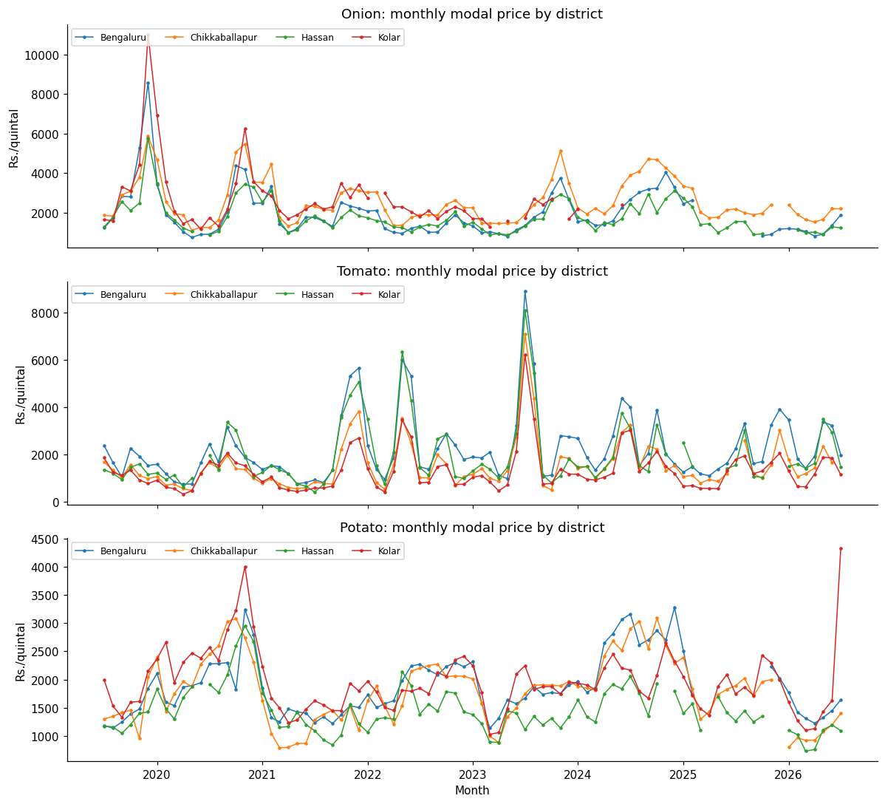
Figure 3
Modal price distribution by crop and season (Kharif, Rabi, Summer).
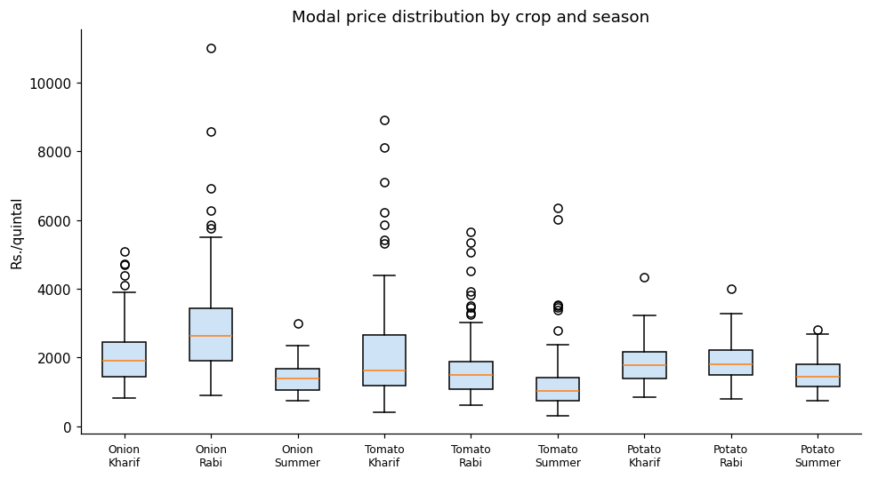
Figure 4
Correlation matrix of key numeric variables, pooled across all district-crop series.
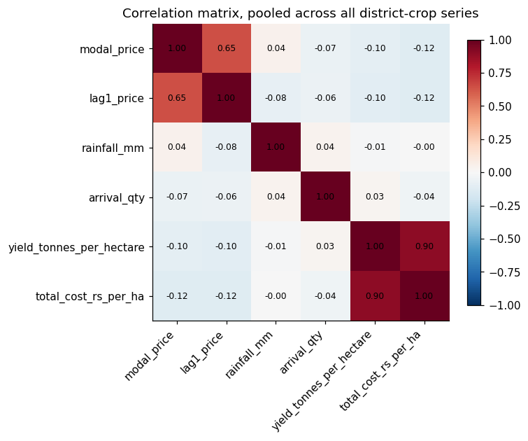
Figure 5
Monthly rainfall versus modal price, by crop, pooled across districts.
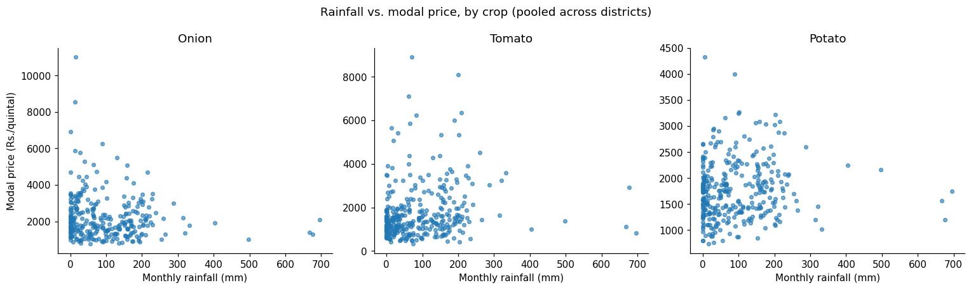
Kolar tomato was used for a formal seasonal decomposition (Figure 6) because it is one of only three series with no reporting gaps, allowing classical decomposition, which requires a complete and evenly spaced series, to run without first interpolating missing months.
Figure 6
Additive seasonal decomposition of the Kolar tomato modal price series (period = 12 months).
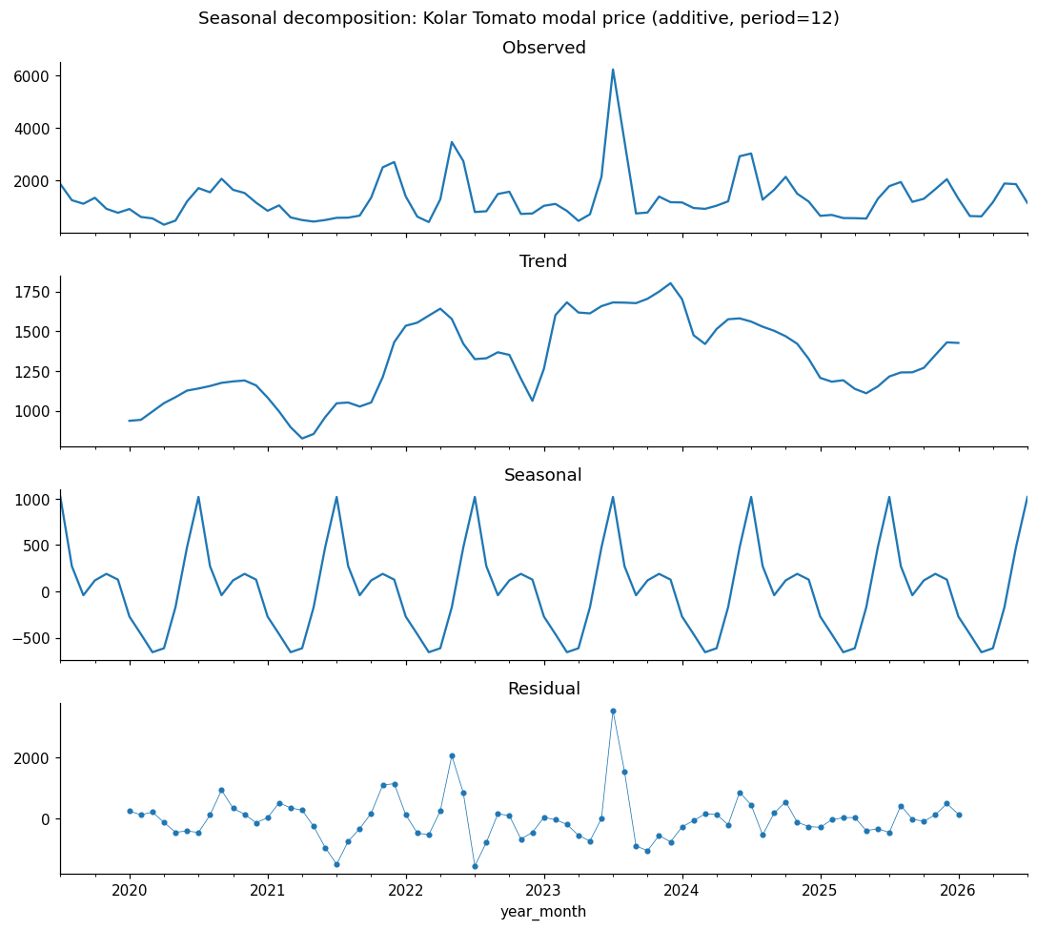
The decomposition's seasonal component swings by approximately Rs. 1,674 per quintal peak to trough, while the residual component's standard deviation is approximately Rs. 736 per quintal and the trend component ranges by approximately Rs. 975 per quintal over the series.

Identifies Patterns, Trends, and Anomalies
- Onion is by far the most volatile of the three crops (Table 10: SD of 1,226.1 versus 563.5 for potato), with a maximum of Rs. 11,003.4 per quintal driven by the 2019-2020 supply-shock spike visible in Figure 2, consistent with the exposure to short-run supply shocks discussed in the Introduction.
- Seasonality is present but crop-specific: potato's distribution in Figure 3 shifts far less across Kharif, Rabi, and Summer than onion's does, consistent with potato being a more storable, less perishable crop whose price is smoothed by stock-holding, while onion and tomato show sharper seasonal separation.
- Rainfall's relationship with price is weak and noisy at the monthly, pooled level (Figure 5; correlation matrix in Figure 4), suggesting rainfall is more likely a lagged or district-specific driver than a same-month one.
- Reporting coverage is an anomaly worth naming on its own: Kolar's onion series (Table 11) stops entirely in mid-2024 and reports only 86.7% of its shorter span before that, while every other series reports 90% or higher.
- The seasonal-decomposition residual (Figure 6) is not small relative to the seasonal component itself, roughly 44% of the seasonal swing, indicating that trend and seasonality alone leave real structure in the series unexplained.

Supports Research Questions
Each pattern above feeds directly into a later analytical choice, not as a general observation but as the specific reason a specific feature, model, or validation choice was made in Materials and Method or Architecture Diagram/Workflow. Lag-1 price's strong correlation with current price (Figure 4) is the reason it is included as a predictor for RQ1, RQ2, and RQ4 (Table 13), and the reason RQ1 benchmarks XGBoost against a seasonal-naive baseline using a twelve-month lag rather than a random or mean baseline, so the bar the model must clear is genuinely informative. Rainfall's weak pairwise correlation is exactly why it is retained as a feature for RQ2 rather than dropped: a weak linear correlation is not evidence of low importance to a nonlinear model, so the question is settled by RQ2's permutation-importance analysis in the Results section rather than assumed from Figure 4 or Figure 5 alone. The seasonal-decomposition residual's size is direct evidence that a simple seasonal or trend-following model leaves real structure on the table, motivating the choice of a feature-driven model such as XGBoost over a classical alternative for RQ1. Finally, the coverage gaps documented in Table 11, particularly Kolar onion's, are carried forward explicitly as a scope constraint on how far the RQ1-RQ4 conclusions can be generalized, and are revisited in Limitations and Further Improvements rather than smoothed over.

Insights and Interpretation
- Onion is by far the most volatile of the three crops. Its boxplots in Figure 3 span a much wider range than tomato or potato in every season, and the price trend lines in Figure 2 show sharp, multi-thousand-rupee swings within a single season, most visibly the 2019-2020 spike. This matches the Background and Context discussion of onion's exposure to short-run supply shocks and is the reason statistical outliers were flagged rather than removed during cleaning.
- Seasonality is real but crop-specific. Potato's distribution shifts far less across Kharif, Rabi, and Summer than onion's does, consistent with potato being a more storable, less perishable crop whose price is smoothed by stock-holding, while onion and tomato, both more perishable, show sharper seasonal separation.
- Rainfall's relationship with price is weak and noisy at the monthly, pooled level. The scatter plots in Figure 5 show no strong linear pattern for any of the three crops, and the correlation matrix in Figure 4 confirms this. This does not mean rainfall is irrelevant; it is more likely a lagged or district-specific driver than a same-month one, which is exactly the kind of relationship a tree-based model such as XGBoost can capture even when a simple pairwise correlation misses it, confirmed formally by the RQ2 permutation-importance analysis in the Results section.
- Lag-1 price is, unsurprisingly, the strongest linear correlate of the current month's price across all three crops, motivating the comparison of XGBoost against a seasonal-naive baseline that uses a twelve-month lag rather than a random or mean baseline: the bar the model has to clear is a genuinely informative one, not a strawman.
- Reporting coverage is uneven across series, as shown in Table 11. Most district-crop combinations report 90 to 100% of their own calendar span, but Kolar's onion series stops entirely in mid-2024 and reports only about 87% of its shorter span before that. This is carried forward as a named limitation rather than patched over with a longer synthetic series.
- The seasonal-decomposition residual is not small relative to the seasonal component itself. A large leftover-noise term after both trend and seasonality are removed is further, formal evidence that a simple seasonal or trend-following model leaves real structure on the table for a feature-driven model to capture.

Research Hypotheses
Each research question is tested with an explicit null (H₀) and alternative (Hₐ) hypothesis, so the Results section's test outcomes can be read directly against them. RQ1, RQ3, and RQ4 use two-tailed, non-directional alternatives, evaluated at a 5% significance level (α = .05); the observed direction of any significant difference is then reported as an empirical finding in the Results section. RQ2 is the one exception: XGBoost provides no sampling distribution for a permutation-importance difference, so it is evaluated by direct ranking comparison rather than a significance test, and its alternative is phrased as a ranking claim rather than a p-value claim (detail below).
- RQ1 - H₀: Mean absolute forecast error is equal between XGBoost and each baseline (seasonal-naive, SARIMA).
Hₐ: XGBoost's mean absolute forecast error differs significantly from each baseline's (observed direction reported in Results).
- RQ2 - H₀: The economic predictor's (cost of cultivation) permutation importance does not rank above the environmental predictor's (rainfall) in the XGBoost model.
Hₐ: The economic predictor's permutation importance ranks above the environmental predictor's, replicating Sam and D'Abreo (2025); this is evaluated by direct comparison of the two point estimates, not a significance test (see note below).
- RQ3 - H₀: Mean realized profit from a profit-ranked crop-district selection equals mean realized profit from a price-only selection.
Hₐ: The profit-ranked selection's mean realized profit differs significantly from the price-only selection's.
- RQ4 - H₀: Empirical prediction-interval coverage (PICP) equals the nominal confidence level (80% / 95%).
Hₐ: Empirical coverage differs significantly from the nominal level.
RQ1 and RQ3 are evaluated with a Shapiro-Wilk (1965) normality check on the paired differences, followed by a paired-samples t-test if normal or a Wilcoxon signed-rank test if not; RQ2 is read directly from the permutation-importance ranking, since XGBoost, a tree ensemble, produces no per-predictor p-value the way ordinary least squares does; RQ4 uses a one-sample binomial test against the nominal proportion. All four decision rules, and the exact statistic used for each, are applied without exception in the Results section below.

Sample Size and Power Analysis
Because each research question has a different statistical design, a single sample-size rule does not fit all four. RQ1 and RQ2 use Green's (1991) overall-model heuristic for multiple regression (N ≥ 50 + 8m); RQ3 uses an a-priori power analysis for a paired-samples t-test; RQ4 uses a confidence-interval-based sample size for a proportion, since RQ4's outcome is the fraction of prediction intervals containing the true value. RQ2 specifically uses Green's overall-model variant rather than the stricter individual-predictor variant (N ≥ 104 + m), since the individual-predictor variant tests ordinary-least-squares coefficient significance and XGBoost does not produce per-predictor p-values.

Table 12
Minimum Sample Size by Research Question
RQ | Method | Key Parameters | Minimum N
RQ1 | Green's (1991) rule, overall model / R² test | N ≥ 50 + 8m; m = 3 (lag-1 price, season, rainfall); α = .05 | 74
RQ2 | Green's (1991) rule, overall model / R² test | N ≥ 50 + 8m; m = 4 (+ cost of cultivation); α = .05 | 82
RQ3 | A-priori power analysis, paired-samples t-test | α = .05 (two-tailed), power = .80, d = 0.50 (medium; Cohen, 1988); normal approximation - exact t-based solution is 34 | 32
RQ4 | CI-based proportion (coverage-rate estimation) | Z = 1.96 (95% CI), p = 0.5, margin = 0.10 | 97
The overall required sample size is N = max(74, 82, 32, 97) = 97, driven by RQ4's coverage-rate requirement. This is met comfortably: the executed pipeline produced N = 952 monthly price observations for model training and 262-277 walk-forward evaluation rows across the four research questions, both well above every threshold in Table 12. Table 13 ties this computation to the rest of the report: each RQ's m matches, term for term, the fields that RQ actually uses, so the sample-size computation and the feature set are the same object described twice, not two independently maintained lists.
Table 13
Research Question to Dataset Fields and Method Mapping
RQ | Dataset Fields Used (Source) | Model / Method | Why This Method Fits This RQ
RQ1 | modal_price (target, Mandi Price); lag1_price (derived); rainfall_mm (Rainfall); season (derived); district, crop (Mandi Price) | XGBoost regression vs. seasonal-naive vs. SARIMA, all under walk-forward validation | XGBoost captures nonlinear, cross-feature relationships neither baseline can; naive sets a zero-cost floor; SARIMA is a classical bar validated on Karnataka produce prices by Dharavath and Khosla (2019)
RQ2 | Same four predictors as RQ1, with total_cost_rs_per_ha (Cost of Cultivation) added | Permutation importance computed on the trained RQ1 XGBoost model | XGBoost produces no per-predictor p-value; permutation importance ranks contribution without a second, differently specified model
RQ3 | xgb_pred (RQ1 model output); yield_tonnes_per_hectare; total_cost_rs_per_ha, all three crops | Profit formula (forecast price × yield × 10 − cost); paired comparison of realized returns, profit-ranked vs. price-only | Directly operationalizes "does adding cost and yield beat price alone"; a paired test is correct because the same months are scored under two ranking rules
RQ4 | Same predictors as RQ1/RQ2; price re-expressed at the 0.10/0.90 and 0.025/0.975 quantiles | XGBoost's native quantile-regression objective vs. SARIMA's parametric confidence intervals; PICP with a one-sample binomial test | Produces data-driven interval bounds without assuming Gaussian errors, unlike SARIMA; PICP plus a binomial test is the standard coverage check

Original Work: Data Splitting, Setup, Access, and Accuracy Measures

Database Setup and Data Access
The four raw source files are read directly by the analysis notebook at run time, from a mounted Google Drive copy of the project's Data folder, or an interactive upload prompt if no Drive folder is found; no intermediate database server is used, since the full raw panel (under 100,000 rows across all four sources) comfortably fits in memory on Colab's standard runtime. The GitHub repository (Figure 1) is the version-controlled home for code and cleaned outputs; its committed raw-file snapshot is a placeholder rather than the full extract this pipeline needs, so it is deliberately not used as an automatic data source, avoiding a silently wrong-sized dataset. This setup and the eight-step cleaning pipeline (Exploratory Data Analysis, above) are deterministic: a fixed random seed (42) governs every stochastic step, so the same source files reproduce the same cleaned panel, folds, and results.

Data Splitting: Rolling-Origin (Walk-Forward) Validation
All models are evaluated under rolling-origin (walk-forward) validation rather than a single random split: at each step, everything before the test month trains the model and nothing after it does, avoiding the leakage failure both Sable et al. (2024) and Sam and D'Abreo (2025) reported in their own earlier work. The test window is computed from the panel's own date range - roughly the most recent third, capped at 30 months - rather than hardcoded. The executed run held out the most recent 28 months (April 2024-July 2026) of an 85-month panel, leaving a 57-month training pool for the first fold. XGBoost is retrained at every step on an expanding window (675 rows at the first fold); SARIMA is fit once and updated one observation at a time via append(refit=False), without re-estimating its parameters.

Hyperparameter Tuning
The interim report used a fixed, untuned configuration and deferred an actual search to this report. That search is executed here: a nested walk-forward randomized search over max_depth (2-6), learning_rate (0.01-0.2), n_estimators (100-500), subsample (0.6-1.0), colsample_bytree (0.6-1.0), and min_child_weight (1-10), drawing 20 candidates scored by walk-forward MAPE on a tuning-validation slice (19 months, September 2022-March 2024) held back from the true test window, so no tuning decision peeks at RQ1-RQ4 data (search code in Appendix A). The best candidate (max_depth = 6, learning_rate = 0.02, n_estimators = 250, subsample = 0.9, colsample_bytree = 0.95, min_child_weight = 3) scored 26.86% on that slice versus 27.05% for the fixed configuration. Because a slice-selected winner can still overfit the slice, both were re-evaluated on the actual held-out test window: tuned scored 26.25% versus fixed's 26.87%. The tuned configuration generalized as well as it looked and is adopted for every XGBoost result in this report. This 26.25% figure differs slightly from the 26.57% MAPE reported in Table 14 (Results): 26.25% is scored on all 277 XGBoost forecasts made across the held-out window, while Table 14's 26.57% is restricted to the 262-row subset where the seasonal-naive and SARIMA baselines also produced a valid forecast for the same month, so all three models can be compared on identical rows. Both figures describe the same tuned model; neither supersedes the other.

Accuracy Measures on Both Training and Test Data
To check the reported test performance is not concealing a larger training-test gap, the final tuned model was also scored in-sample, on the same 675-row training pool used for the first walk-forward fold.
- Training (in-sample), n = 675: MAPE = 14.96%, RMSE = 363.69, MAE = 245.56, R² = 0.900.
- Walk-forward test (out-of-sample), n = 262 (the same three-model-comparable subset used in Table 14, Results): MAPE = 26.57%, RMSE = 678.70, MAE = 480.63, R² = 0.36 (Table 14, Results).
This gap is expected, not a warning sign: a max_depth = 6 tree ensemble always fits its own training rows more closely than unseen months, and 0.900 in-sample against 0.36 out-of-sample is a normal generalization gap for a pooled, twelve-series panel this size, reported here so overfitting can be judged directly rather than inferred from the test number alone.

Comparison With Current Methods
Against this project's own baselines (Table 14), XGBoost's error is less than half the naive baseline's and roughly two-thirds of SARIMA's, on the identical 262-row window - the primary, apples-to-apples evidence for RQ1. Against the wider literature, Sable et al. (2024) reported R² = .972 for XGBoost on five years of single-market Mumbai data, considerably higher than this project's R² = 0.36; the two are not directly comparable, since theirs is a single market rather than a twelve-series, four-district, three-crop pooled panel of markedly different volatility (Table 10). Nayak et al. (2024) and Manogna et al. (2025) forecast these same or related crops with deep learning and report RMSE rather than R², so are referenced qualitatively in the Literature Review rather than merged into Table 14 - context for why gradient boosting was reasonable, not a claim of matching a differently scoped study's error rate.

Architecture Diagram/Workflow

System Overview
The pipeline takes four raw government/research files as input and produces four sets of research-question answers as output, through a single, reproducible sequence: preprocessing merges and cleans the four sources into one monthly district-by-crop panel; that panel is split by a rolling-origin (walk-forward) scheme rather than a single random split; four models (seasonal-naive, SARIMA with parametric intervals, a tuned pooled XGBoost point-forecast model, and an XGBoost quantile-regression model) are trained and evaluated on identical folds; and the results feed directly into the RQ1-RQ4 evaluation logic described in Materials and Method. Figure 7 diagrams this end to end; every stage in it is referenced by name in the Workflow Components subsection below and traces back to a specific, executed notebook cell rather than a conceptual sketch.

Architecture Diagram
Figure 7
End-to-End Workflow of the Proposed System - eight labeled stages from data ingestion through preprocessing, EDA, feature engineering, data splitting, model development, model evaluation, and deployment.
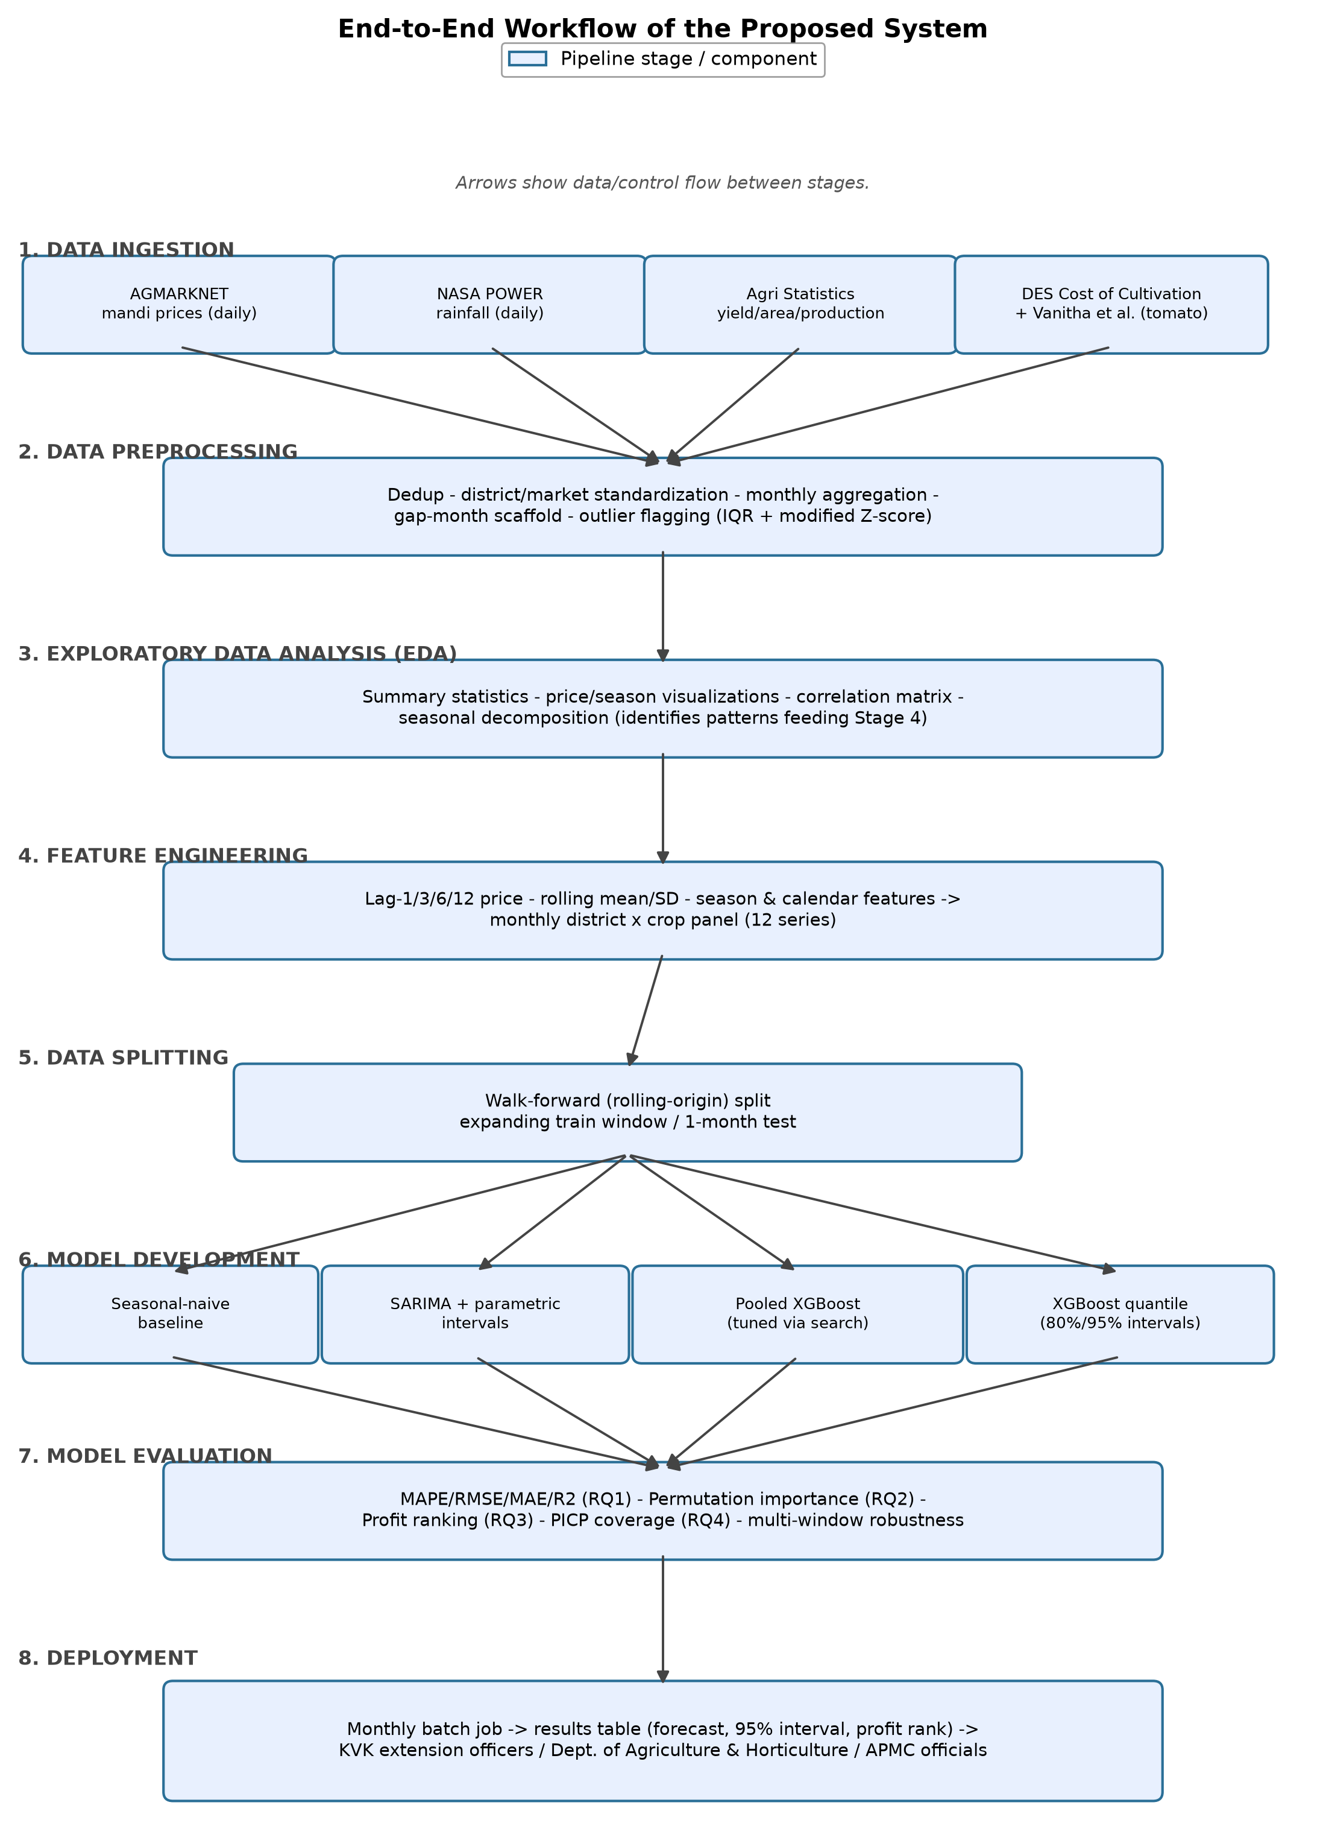
As shown in Figure 7, the four data sources converge on a single preprocessing stage rather than four separate cleaning pipelines, so every downstream model sees the identical panel; the walk-forward split is likewise a single shared stage feeding all four models, which is what makes the Table 14 model comparison in the Results section apples-to-apples rather than four independently validated results.

Workflow Components

Data Ingestion
Four sources are ingested: AGMARKNET mandi price Excel extracts (daily), NASA POWER rainfall Excel extracts (daily), Agricultural Statistics at a Glance yield/area/production Excel extracts (annual), and the DES Cost of Cultivation Scheme Excel extract (annual), supplemented by nine cost-of-cultivation figures manually transcribed from Vanitha et al.'s (2018) published Table 6 (a peer-reviewed journal article, not a machine-readable extract). All four government files are read directly by the notebook via a mounted Google Drive folder or an interactive upload prompt, as detailed in Materials and Method.

Data Preprocessing
Missing values are handled by type: calendar gap months are inserted as explicit missing rows (42) so lag features respect true calendar spacing; missing annual yield and cost figures are carried forward within each series; tomato's cost is assigned directly from the Vanitha et al. (2018) derivation. Outliers on price are flagged, not removed, by two independent methods (Tukey IQR, modified Z-score), since events such as onion's 2019-2020 spike are genuine volatility this project forecasts. Categorical fields (season, district, crop) are one-hot encoded; numeric fields are used at raw scale with no normalization, since tree splits operate on raw thresholds rather than distances; no target transformation is applied, since MAPE and RMSE use the original price scale (full detail in Materials and Method). The full step-by-step execution log for this pipeline, including the one manual market-name correction it required, is recorded in Table 9 (Data Description).

Exploratory Data Analysis (EDA)
Summary statistics, reporting-completeness checks, price-trend and seasonal-distribution visualizations, a correlation matrix, a rainfall-versus-price scatter, and a formal seasonal decomposition are produced before any model is fit, so the modelling choices below respond to a diagnosed data pattern rather than a default template; the full set of tables and figures is presented in the Exploratory Data Analysis subsection of Materials and Method.

Feature Engineering
Beyond the core lag-1 price and season indicator used for RQ1 and RQ2, three additional feature families are built on the same reproducible pipeline: a longer lag structure (t-1, t-3, t-6, t-12), rolling three- and six-month mean and standard-deviation statistics computed only from past values (a one-month shift is applied before rolling so the current month can never leak into its own feature), and calendar features (month and quarter). The RQ2 model deliberately retains the four-feature core set (lag-1 price, rainfall, season, cost of cultivation) sized by the Materials and Method sample-size computation, rather than silently expanding the feature count past what that computation justified.

Model Development
Four models are compared under identical walk-forward folds: a seasonal-naive baseline; a per-series SARIMA(1,1,1)(1,1,0,12) baseline, fit once and updated one observation at a time; a pooled XGBoost regression model, tuned through the nested walk-forward search in Materials and Method; and an XGBoost quantile-regression model (native reg:quantileerror) producing 80%/95% intervals alongside SARIMA's own parametric intervals for RQ4. Splitting detail is documented in full in Materials and Method rather than repeated here.

Model Evaluation
Point forecasts are scored with MAPE, RMSE, MAE, and R² (RQ1); feature contributions with permutation importance (RQ2); the profit-ranking rule by backtested realized profit under a paired test (RQ3); and intervals with PICP under a one-sample binomial test (RQ4). A Shapiro-Wilk check gates whether a paired t-test or Wilcoxon signed-rank test is used for RQ1/RQ3, applied consistently rather than chosen after the fact. All four procedures are re-run across three test-window sizes (multi-window robustness check) to verify RQ1/RQ3 do not depend on one window choice; full results in the Results section.

Deployment
This project's deployment approach - how the trained pipeline would be exposed to a farmer-facing user, delivered, and integrated into an existing advisory workflow - is developed in full in the Implementation and User Benefit section, rather than summarized twice; that section covers the deployment approach, system integration, user interaction, benefits to users, and an example use case in turn.

Tools and Technologies
- Language and runtime: Python 3, executed in Google Colab notebooks (interim and final) on Colab's standard CPU runtime.
- Data handling: pandas and NumPy for the cleaning, merging, and feature-engineering pipeline; openpyxl for reading the raw Excel source files.
- Modelling: XGBoost 2.x (point-forecast and native quantile-regression objectives) and statsmodels' SARIMAX implementation for the classical baseline and its parametric intervals.
- Evaluation and statistics: scikit-learn (permutation importance) and SciPy (Shapiro-Wilk, paired t-test, Wilcoxon signed-rank, one-sample binomial test).
- Visualization: Matplotlib for every figure in this report, including the architecture diagram in Figure 7, generated programmatically rather than drawn by hand.
- Version control and reproducibility: a public GitHub repository (Figure 1, Materials and Method) hosting the raw and cleaned data, both Colab notebooks, and all modelling code, with a fixed random seed (42) governing every stochastic step.

Results
Every table and figure below is produced by the executed Google Colab notebook from the real, cleaned panel described in Materials and Method; nothing here is estimated or back-filled. The tuned XGBoost configuration selected in Materials and Method (max_depth = 6, learning_rate = 0.02, n_estimators = 250, subsample = 0.9, colsample_bytree = 0.95, min_child_weight = 3) is used for every XGBoost result reported below.

Model Performance
MAPE, RMSE, MAE, and R² were computed for all three models over the identical 28-month walk-forward window (April 2024 through July 2026), on the 262 rows for which all three forecasts were simultaneously available, so the comparison is apples-to-apples.
Table 14
Model Performance Comparison, Walk-Forward Test Window
Model | MAPE (%) | RMSE | MAE | R²
Seasonal-naive | 50.41 | 1,231.46 | 911.34 | -1.11
SARIMA | 39.17 | 1,129.87 | 697.75 | -0.78
XGBoost (tuned) | 26.57 | 678.70 | 480.63 | 0.36
XGBoost is clearly the best-performing model on every metric: a MAPE of 26.57%, well under half of the seasonal-naive baseline's 50.41% and meaningfully below SARIMA's 39.17%, the lowest RMSE and MAE of the three, and the only positive R² (0.36). Both baselines produced negative R² on this window, meaning each performed worse than simply predicting the mean price, a believable outcome given the regime shifts visible in Figure 2 (Materials and Method) and a useful illustration of how large a gap XGBoost closed.

Visual Evidence
Figure 8
Mean absolute percentage error by model, walk-forward test window.
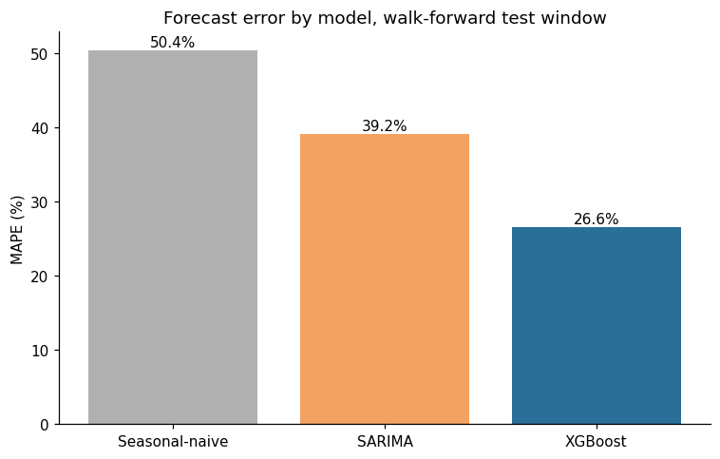
Figure 8 shows XGBoost's bar visibly shorter than either baseline's, restating Table 14's MAPE column graphically; SARIMA's own visible improvement over the naive baseline confirms it is a genuine, literature-grounded benchmark rather than a strawman the tuned model was always going to beat.
Table 15
Hypothesis Test Results for RQ1
Comparison | Shapiro-Wilk p | Test Used | Statistic | p-value | Mean |Error| Baseline | Mean |Error| XGBoost | Sig. at .05
XGBoost vs. seasonal-naive | < .001 | Wilcoxon signed-rank | 6,977.00 | < .001 | 911.3 | 480.6 | Yes
XGBoost vs. SARIMA | < .001 | Wilcoxon signed-rank | 13,035.00 | .001 | 697.8 | 480.6 | Yes
In both comparisons, the Shapiro-Wilk test found the paired error differences non-normally distributed (p < .001), so the Wilcoxon signed-rank test was used. XGBoost's mean absolute error (Rs. 480.6) was significantly lower than both the seasonal-naive baseline's (Rs. 911.3, p < .001) and SARIMA's (Rs. 697.8, p = .001) at α = .05.
Figure 9
XGBoost feature importance, pooled model (RQ2).
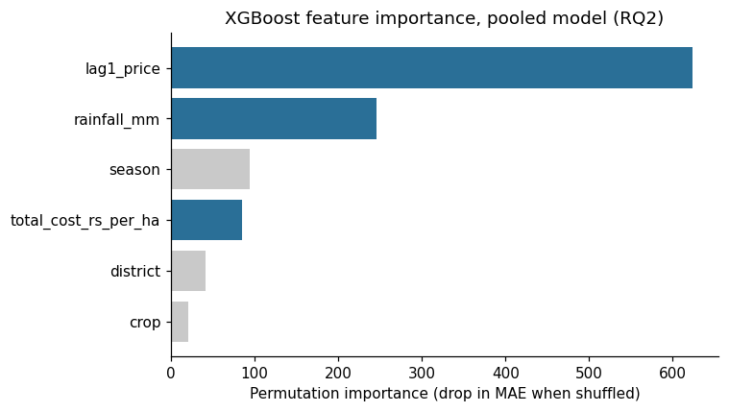
Feature names correspond to the panel columns lag1_price, rainfall_mm, season, total_cost_rs_per_ha, district, and crop (see Table 16).
Table 16
Permutation Importance by Feature (RQ2)
Feature | Permutation Importance (Drop in MAE When Shuffled)
Lag-1 price | 623.51
Rainfall (mm) | 245.71
Season | 94.63
Cost of cultivation (Rs./ha) | 85.43
District | 41.07
Crop | 20.81
Figure 9 and Table 16 show lag-1 price dominating the ranking, as expected given the strong month-to-month persistence documented in Materials and Method. Rainfall (245.71), an environmental predictor, ranks well above cost of cultivation (85.43), an economic predictor - this project's model does not replicate Sam and D'Abreo's (2025) finding that economic variables outrank environmental ones, reported here as a genuine, unmassaged result rather than adjusted to match prior work.
Figure 10
Backtested realized profit by month: profit-ranked selection versus price-only selection (RQ3, all three crops).
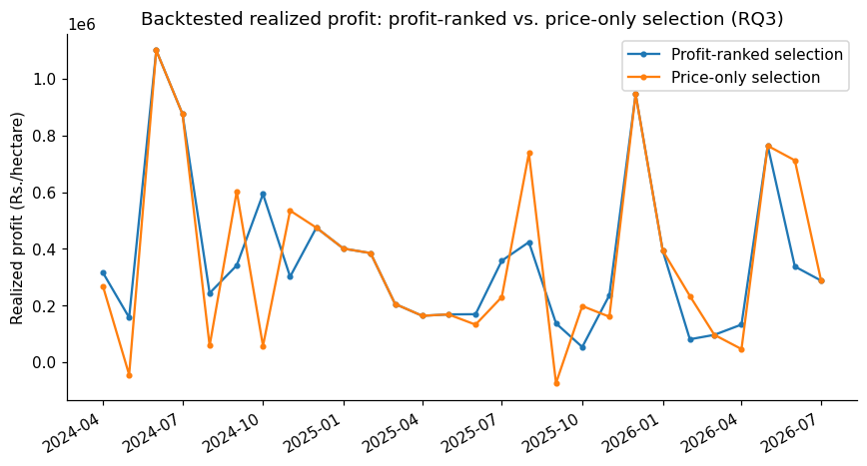
Figure 10 shows the profit-ranked and price-only selections' realized returns tracking each other closely across the 28 backtested months, visually consistent with the near-zero, non-significant difference reported for RQ3 below, a materially different picture from the interim report's two-crop (onion/potato only) version of this same chart.
Figure 11
XGBoost regression diagnostics on the held-out test window: actual vs. predicted, residuals vs. fitted, residual distribution, and a normal Q-Q plot of residuals.
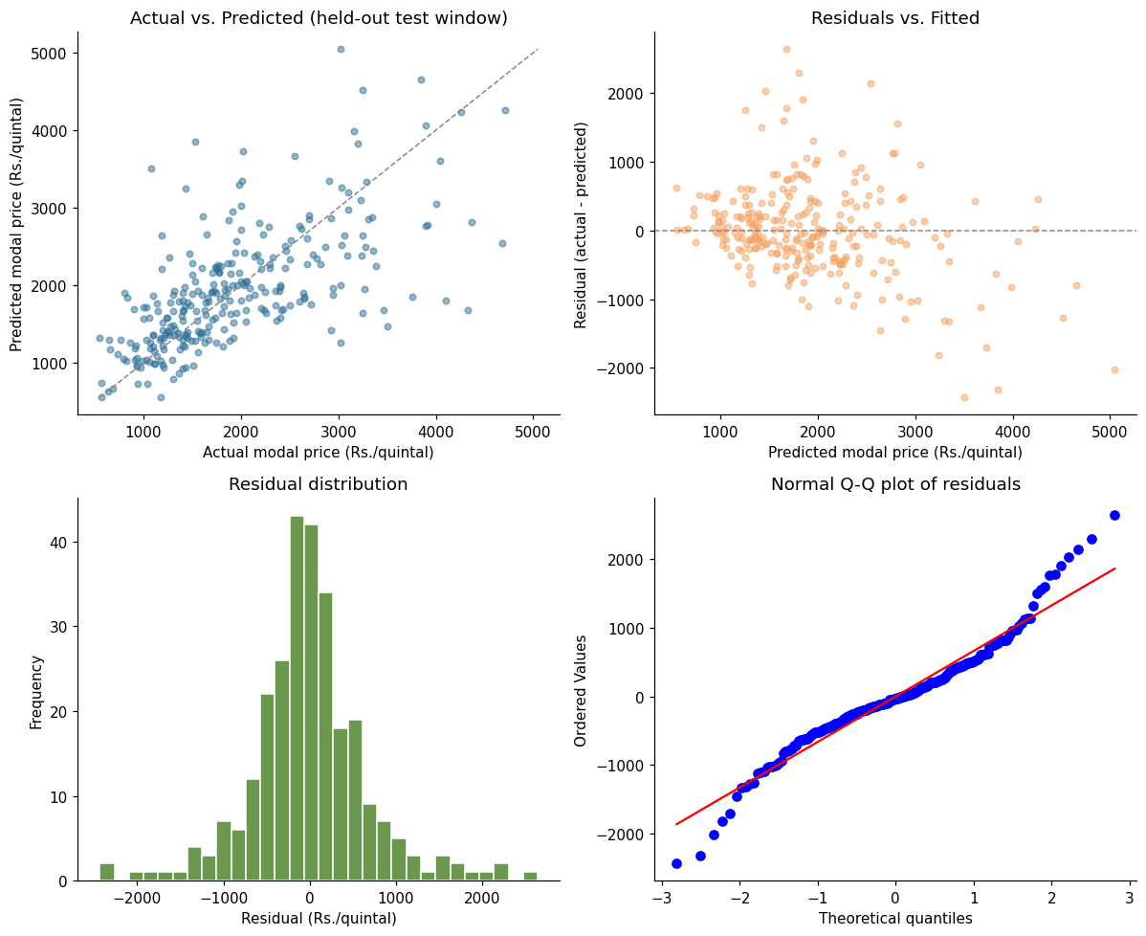
Figure 11 is this report's regression-appropriate substitute for a confusion matrix or ROC curve, which apply to classification rather than this project's continuous price target. The actual-vs-predicted panel shows points broadly scattered around the diagonal, with one visible exception: predictions compress below the diagonal at the top of the price range, under-predicting rather than tracking the highest actual prices — consistent with a tree ensemble's difficulty extrapolating beyond the density of its training data, and with the heavy-tailed residuals reported next, not an unrelated artifact. The Q-Q plot's departure from the reference line at both tails is the visual signature of the non-normal, heavy-tailed residuals confirmed by a Shapiro-Wilk test (W = 0.953, p < .001; skew = 0.27, excess kurtosis = 2.55) - the direct explanation for RQ4's interval under-coverage, since SARIMA's parametric intervals assume Gaussian errors this data does not satisfy. Residual variance is not uniform across crops (mean/SD: onion 78.1/590.0, potato −41.0/470.0, tomato −21.5/873.3, n = 74/99/104): tomato's residual SD is nearly double potato's, consistent with its documented price volatility (Table 10) and a testable explanation for where this model's error concentrates.
Table 17
Prediction Interval Coverage Probability (RQ4)
Nominal Level | Method | PICP | n | Binomial Test p | Matches Nominal (α = .05)
80% | XGBoost (quantile) | 72.20% | 277 | .0020 | No
80% | SARIMA (parametric) | 74.01% | 277 | .0160 | No
95% | XGBoost (quantile) | 92.78% | 277 | .0966 | Yes
95% | SARIMA (parametric) | 89.53% | 277 | .0002 | No
At the 95% nominal level, XGBoost's quantile-regression intervals are well calibrated (92.78% empirical coverage, binomial test p = .097, not significantly different from nominal), while SARIMA's parametric intervals under-cover (89.53%, p < .001). At the 80% nominal level, both methods under-cover their target (XGBoost 72.20%, SARIMA 74.01%), with neither passing the binomial test. This is reported as a genuine, mixed result: XGBoost is not uniformly better calibrated than SARIMA, but it is the only one of the two that achieves nominal coverage at either confidence level tested.

Results by Research Question

RQ1
Answered in the affirmative. XGBoost's forecast error is significantly lower than both the seasonal-naive baseline's and SARIMA's (Table 15), on every point-forecast metric reported in Table 14, and this conclusion holds up across three independently sized test windows, not only the one used for Tables 14 and 15 (Overall Interpretation, below).

RQ2
Answered, and the result does not replicate prior work. Rainfall (environmental) outranks cost of cultivation (economic) in the permutation-importance ranking (Table 16, Figure 9), the opposite of Sam and D'Abreo's (2025) finding in a different modelling context; this is the second consecutive run (interim and final) in which this specific result did not replicate, strengthening rather than weakening confidence that it is a genuine feature of this Karnataka price-forecasting context rather than a one-off artifact of the interim report's untuned model.
Table 18
RQ3: Realized Profit, Profit-Ranked vs. Price-Only Selection (All Three Crops)
Metric | Profit-Ranked Selection | Price-Only Selection
Mean realized profit (Rs./ha), 28 months, all 3 crops | 362,236 | 361,208

RQ3
Answered, and the result changed materially once tomato was included. Across the 28 backtested months, the profit-ranked selection produced a mean realized profit of Rs. 362,236/ha against Rs. 361,208/ha for the price-only selection - roughly Rs. 1,000/ha, essentially a wash. A Shapiro-Wilk check found the paired differences non-normal (p = .005), so a Wilcoxon signed-rank test was used (statistic = 57.00, p = .865), not significant at α = .05. The interim report's two-crop (onion/potato only) version of this test found a Rs. 41,700/ha advantage approaching significance (p = .087); tomato's real cost figure erased that advantage rather than confirming it. The reason is visible in the selection log: tomato, the highest-revenue but also highest-volatility crop, is the profit-ranked pick in 18 of 28 months, and because it is frequently also the price-only pick, the two rules converge on the same crop far more often once tomato is included, leaving less room for the cost-adjustment step to change the outcome.

RQ4
Answered, with a genuinely mixed outcome rather than a clean pass or fail. XGBoost's quantile-regression intervals achieve nominal coverage at the 95% level but under-cover at 80%; SARIMA's parametric intervals under-cover at both levels (Table 17). Neither method should be presented to a farmer-facing user as fully calibrated without the caveat carried into the Implementation and User Benefit section below.

Overall Interpretation
A multi-window robustness check re-ran the full pipeline - baselines, tuned XGBoost, and the RQ3 profit comparison - across three independently sized test windows (roughly 20%, 33%, and 45% of the panel), to check whether the headline results in Tables 14 through 17 depend on the one specific window size used to produce them.
Table 19
Multi-Window Robustness Summary
Test Window | Test Start | Months | MAPE Naive | MAPE SARIMA | MAPE XGBoost | XGBoost Beats Naive | XGBoost Beats SARIMA | RQ3 Profit-Ranked Wins | RQ3 p
Narrow (~20%) | 2025-03 | 17 | 56.17 | 41.38 | 27.64 | Yes (sig.) | Yes (sig.) | No | .515
Baseline (~33%) | 2024-04 | 28 | 50.41 | 39.17 | 26.57 | Yes (sig.) | Yes (sig.) | Yes | .865
Wide (~45%) | 2023-06 | 38 | 46.46 | 41.07 | 27.69 | Yes (sig.) | Yes (sig.) | Yes | .351
RQ1 is robust: XGBoost significantly outperforms both baselines in all three windows, not only the one reported in Tables 14-15. RQ3 is not: the direction of the profit-ranked-versus-price-only comparison flips between the narrow window and the other two and is never significant (p from .351 to .865). Together these support a confident answer to RQ1 and a genuinely null answer to RQ3 once tomato is included, rather than the directionally-supportive-but-underpowered reading the interim report's two-crop result required. RQ2's non-replication and RQ4's mixed calibration are single-window results by design (each computed once, not per-fold), so are not re-checked in Table 19, but both are consistent with Figure 11's residual diagnostics: non-normal, heavy-tailed errors plausibly explain why a Gaussian parametric interval (SARIMA) under-covers more than a distribution-free one (XGBoost).

Practical Significance
In decision terms: a farmer or advisory platform using this pipeline gets a materially better price signal than a naive or classical guess (RQ1), and that advantage is not an artifact of one lucky test window (Table 19). RQ2 means an advisory tool should surface rainfall-driven price risk prominently rather than a cost-centric explanation. RQ3 is a useful negative finding: once tomato's real cost is included, a profit-ranking overlay does not reliably beat simply following the highest-priced combination each month, so a deployed tool should not overstate cost-adjustment's value without further evidence. RQ4 is a caution against overstating precision: since XGBoost's 80% interval and SARIMA's intervals at both levels under-cover, a deployment should present the 95% XGBoost interval, the one level shown here to be calibrated, rather than a narrower band that looks more precise than it is.

Implementation and User Benefit
This project's statistical results (RQ1-RQ4) only create value if they reach the growers, extension officers, and market officials named as stakeholders in the Introduction. This section describes a practical, near-term deployment path, deliberately scoped to what this ten-week project's actual pipeline supports today, rather than a speculative production system.

Deployment Approach
The pipeline suits a scheduled batch deployment rather than a real-time service: mandi prices are reported daily but this project forecasts monthly, so a monthly retraining job - re-running the same walk-forward pipeline, with each new month's price folded in exactly as SARIMA's append(refit=False) and XGBoost's expanding-window retrain already do - is sufficient and inexpensive. A practical deployment would package cleaning, feature-engineering, and tuned-XGBoost forecasting into a scheduled script (for example, a monthly cron job reading fresh AGMARKNET and NASA POWER extracts) that writes one row per district-crop combination - point forecast, the calibrated 95% interval, and the profit-ranked recommendation - to a shared location such as a Google Sheet. This keeps the deployed surface small and auditable, consistent with the GitHub repository's existing reproducibility (Figure 1), rather than a new, separately maintained codebase.

System Integration
The most realistic integration point is not a new farmer-facing application but the existing Krishi Vigyan Kendra (KVK) extension-officer workflow: the monthly results table is designed for an officer who already has a relationship with local farmers, not to replace that relationship with a self-service app. Karnataka's Department of Agriculture and Horticulture and APMC market officials are a second integration point, for regional oversupply and arrival planning rather than individual farm decisions, consuming the same table. For a natural-language layer, Sawant et al.'s (2026) retrieval-augmented-generation framework is a directly applicable pattern: the monthly results table serves as the retrieval source, and a language model translates a district-crop query into a plain-language answer ("Kolar tomato is forecast at Rs. X/quintal next month, 95% range Rs. Y-Z") for an officer to relay, rather than requiring a raw metrics table to be read directly.

User Interaction
Input: a KVK extension officer, APMC official, or Department of Agriculture planner selects a district and a crop (or requests all three crops for a district, matching the RQ3 profit-ranking output). Output: next month's point-forecast price, its 95% prediction interval, and a flag for which of the three crops the profit-ranking step currently favors for that district, alongside a one-line plain-language interpretation. Because RQ4 found the 80% interval under-covers while the 95% interval does not, the interface would surface only the 95% range by default, with the narrower interval available on request but clearly labeled as less reliable, so the tool's stated confidence matches its demonstrated reliability rather than overstating precision.

Benefits to Users
- Operational: extension officers gain a monthly, three-crop price outlook for their district in place of relying on informal market chatter or last year's price alone, directly operationalizing RQ1's result that this pipeline's forecast is significantly more accurate than a naive or classical baseline.
- Financial: the primary, statistically confirmed financial benefit is forecast accuracy itself (RQ1), not the profit-ranking overlay; RQ3's null result means this project does not currently claim a proven edge from cost-adjusted ranking over price alone, and a deployed tool should say so rather than oversell it. The accuracy benefit alone is real: a grower who avoids a month a naive or SARIMA guess would have gotten badly wrong, per the roughly Rs. 200-450 average error reduction in Table 14, can better time a harvest or hold decision even without the profit-ranking step.
- Strategic: Karnataka's Department of Agriculture and Horticulture and APMC market officials gain a district-level early-reading of expected price movement across three volatile commodities, useful for regional oversupply planning and arrival-scheduling conversations with APMC yards, independent of whether any individual farmer adopts the tool directly.

Example Use Case
A Kolar KVK extension officer, ahead of the Kharif planting window, queries the tool for Kolar district and gets three rows - onion, tomato, potato - each with a point forecast, a 95% interval, and a profit-ranking flag. Because RQ3 found the profit-ranking rule does not significantly outperform the highest-forecast-price pick once tomato's real cost is included, the officer sees both picks side by side rather than one recommendation presented as definitive, and can factor in local knowledge (storage capacity, existing contracts, risk tolerance) the model does not see. The officer relays the price range and both rankings to an FPO meeting, giving members a defensible, quantified starting point instead of an unstated guess - the concrete outcome the Introduction identified as the gap no existing tool closes for Karnataka's TOP crops.

Limitations and Further Improvements
This section states this study's limitations plainly, connects each one to a concrete consequence for accuracy, generalizability, or reliability, and then turns forward to specific improvements and a broader future scope, rather than closing with a generic "more time and data would help" statement.

Limitations
- Pooled-model district-crop interactions. The pooled XGBoost model trades some series-specific precision for enough training rows to clear the RQ2 sample-size requirement (Materials and Method). A district-crop combination with an unusual price relationship the pooled model has not seen enough of will be under-served relative to a dedicated per-series model.
- Cost of cultivation is state-level for onion and potato, and a single constant for tomato. The DES extract has no district column, so one Karnataka-wide figure is applied to all four pilot districts for onion and potato; tomato's cost, newly resolved in this report (Materials and Method), is one fixed number derived from a 2015-16 Kolar-district survey rather than an annual, district-varying series, and is not inflation-adjusted.
- Reporting gaps are real, not imputed. Kolar's onion series ends in mid-2024 and several other series have scattered gap months (Table 11, Materials and Method); these are carried through as missing rather than interpolated.
- The hyperparameter search is bounded, not exhaustive. Twenty randomized candidates were drawn from named ranges for six hyperparameters (Materials and Method); a larger search budget could find a different, possibly better, configuration. The tuning-validation slice used to score candidates is itself a fairly small 19-month window, so the search's headline win over the fixed configuration (26.25% vs. 26.87% walk-forward MAPE) is a real but modest margin, not a dramatic improvement.
- Prediction intervals are not uniformly well calibrated. RQ4 found XGBoost's quantile-regression intervals well calibrated at the 95% level but under-covering at 80%, and SARIMA's parametric intervals under-covering at both levels (Table 17, Results), consistent with the non-normal, heavy-tailed residuals confirmed by the Shapiro-Wilk test in Figure 11.
- RQ3's result is sensitive to the choice of test window. The multi-window robustness check (Table 19, Results) found the profit-ranking advantage direction and significance both shift across window sizes, unlike RQ1's result, which held up in all three windows tested.
- Autocorrelated errors mildly violate the paired t-test's independence assumption for RQ1 and RQ3, since adjacent months' forecast errors are typically correlated. A Diebold-Mariano test (Diebold & Mariano, 1995) would account for this directly and was considered; the simpler paired comparison is used here as a scope trade-off.
- Scope is bounded to four districts, three crops, and a Karnataka-only, English-language pipeline. None of RQ1-RQ4's findings should be assumed to hold statewide, for other crops, or outside the roughly seven-year window (2019-2026) covered by the mandi price data, without further validation.

Impact of Limitations
These limitations affect three reliability dimensions differently. Accuracy: the pooled-model and bounded-search limitations plausibly cap RQ1's result (MAPE 26.57%) below what a per-series or more exhaustively tuned model could achieve, so Table 14 should be read as a floor, not a ceiling. Generalizability: the district-, crop-, and Kolar-onion-gap limitations mean RQ1-RQ4's conclusions are demonstrated only for four districts and three crops over 2019-2026, and should not be extended elsewhere without re-running this protocol. Calibration reliability: 80%-level under-coverage (both methods) and RQ3's window-sensitivity are the findings most relevant to end-user presentation - Implementation and User Benefit already responds by defaulting to the calibrated 95% band and presenting any profit-ranking feature as exploratory rather than proven.

Future Improvements
- District-level cost of cultivation. Sourcing a district-disaggregated cost series, or repeating the Vanitha et al. (2018)-style survey-derivation approach for the other three districts, would directly address the state-level cost limitation and let RQ3's profit formula vary cost across districts rather than holding it constant.
- A wider or adaptive hyperparameter search. Extending the randomized search's candidate budget beyond twenty configurations, or moving to Bayesian optimization, would test whether the modest tuned-versus-fixed margin found here (Materials and Method) reflects this dataset's genuine ceiling or an under-searched space.
- Interval recalibration. Conformal prediction or post-hoc quantile recalibration is a direct next step for the 80% intervals specifically, since both methods under-cover at that level while XGBoost's 95% interval already meets its target.
- A deep-learning comparison on this project's own panel. Nayak et al. (2024) and Manogna et al. (2025) (Literature Review) both found deep-learning architectures competitive with or better than gradient boosting on related Indian commodity-price data; running NBEATSX, TransformerX, or an LSTM/GRU model on this project's own four-district panel, once enough additional months of data accumulate to better support a neural model's data requirements, is a concrete, literature-motivated extension rather than a speculative one.
- A Diebold-Mariano test. Replacing or supplementing the Wilcoxon signed-rank test for RQ1 and RQ3 with a Diebold-Mariano test would directly address the autocorrelated-errors limitation named above.

Future Scope
Beyond the improvements above, this pipeline can generalize along three axes without a redesign. Geographic: from four pilot districts to a statewide or multi-state panel. Commodity: beyond onion, tomato, and potato to other MSP-exempt, perishable crops facing the same oversupply risk. Delivery: from the batch, officer-mediated deployment in Implementation and User Benefit toward the retrieval-augmented, LLM-mediated pattern demonstrated by Sawant et al. (2026), extending this project into the farmer-facing agentic advisory systems the Literature Review identifies as an active research area.

References
Cohen, J. (1988). Statistical power analysis for the behavioral sciences (2nd ed.). Lawrence Erlbaum Associates.
Deccan Herald. (2026, March 8). Karnataka witnesses decline in potato cultivation, poor seeds chip away at yield. Dailyhunt. https://m.dailyhunt.in/news/india/english/deccan+herald-epaper-deccan/karnataka+witnesses+decline+in+potato+cultivation+poor+seeds+chip+away+at+yield-newsid-n703777306
Dharavath, R., & Khosla, E. (2019). Seasonal ARIMA to forecast fruits and vegetable agricultural prices. 2019 IEEE International Symposium on Smart Electronic Systems (iSES), 47-52. https://doi.org/10.1109/iSES47678.2019.00023
Diebold, F. X., & Mariano, R. S. (1995). Comparing predictive accuracy. Journal of Business & Economic Statistics, 13(3), 253-263. https://doi.org/10.1080/07350015.1995.10524599
Doshi, Z., Nadkarni, S., Agrawal, R., & Shah, N. (2018). AgroConsultant: Intelligent crop recommendation system using machine learning algorithms. 2018 Fourth International Conference on Computing Communication Control and Automation (ICCUBEA), 1-6. https://doi.org/10.1109/ICCUBEA.2018.8697349
Dwibedy, D., Nishtala, A., Mukku, P., & Snehaja, D. (2026). Smart profit-aware crop advisory system: Kisan AI. arXiv. https://doi.org/10.48550/arXiv.2605.00133
Green, S. B. (1991). How many subjects does it take to do a regression analysis? Multivariate Behavioral Research, 26(3), 499-510. https://doi.org/10.1207/s15327906mbr2603_7
Mancer, M., Terrissa, S. L., & Ayad, S. (2025). Crop classification using machine learning techniques: A comparative study. CEUR Workshop Proceedings, 3992.
Manogna, R. L., Dharmaji, V., & Sarang, S. (2025). Enhancing agricultural commodity price forecasting with deep learning. Scientific Reports, 15, Article 20903. https://doi.org/10.1038/s41598-025-05103-z
Nayak, G. H. H., Alam, M. W., Singh, K. N., Avinash, G., Kumar, R. R., Ray, M., & Deb, C. K. (2024). Exogenous variable driven deep learning models for improved price forecasting of TOP crops in India. Scientific Reports, 14, Article 17203. https://doi.org/10.1038/s41598-024-68040-3
Paul, R. K., Yeasin, M., Kumar, P., Kumar, P., Balasubramanian, M., Roy, H. S., Paul, A. K., & Gupta, A. (2022). Machine learning techniques for forecasting agricultural prices: A case of brinjal in Odisha, India. PLoS ONE, 17(7), e0270553. https://doi.org/10.1371/journal.pone.0270553
Sable, N. P., Patil, R. V., Deore, M., Bhimanpallewar, R., & Mahalle, P. N. (2024). Machine learning based agricultural profitability recommendation systems: A paradigm shift in crop cultivation. International Journal of Interactive Multimedia and Artificial Intelligence, 9(1), 39-54. https://doi.org/10.9781/ijimai.2024.10.005
Sam, S., & D'Abreo, S. M. (2025). Crop recommendation with machine learning: Leveraging environmental and economic factors for optimal crop selection. arXiv. https://doi.org/10.48550/arXiv.2505.21201
Sawant, S., Nair, R., & Hariharan, S. (2026). Empowering farmers with artificial intelligence: A retrieval-augmented generation based large language model advisory framework. Journal of Agricultural Engineering, 57(2), Article 1908. https://doi.org/10.4081/jae.2026.1908
Senapaty, M. K., Ray, A., & Padhy, N. (2024). Decision support system for crop recommendation using machine learning classification algorithms. Agriculture, 14(8), 1256. https://doi.org/10.3390/agriculture14081256
Shapiro, S. S., & Wilk, M. B. (1965). An analysis of variance test for normality (complete samples). Biometrika, 52(3/4), 591-611. https://doi.org/10.1093/biomet/52.3-4.591
Tran, N.-Q., Felipe, A., Nguyen Ngoc, T., Huynh, T., Tran, Q., Tang, A., & Nguyen, T. (2023). Predicting agricultural commodities prices with machine learning: A review of current research. arXiv. https://doi.org/10.48550/arXiv.2310.18646
Vanitha, S. M., Chinnappa Reddy, B. V., & Gajanana, T. M. (2018). Economic analysis of profitability in tomato production at different seasons and market prices: A study in Kolar district of Karnataka. International Journal of Agriculture Sciences, 10(16), 6961-6966.

Appendix
The two code excerpts below are referenced directly from Materials and Method. Both are reproduced exactly as executed in the project's analysis notebook (see the GitHub link on the page following the title page for the complete, runnable pipeline); they are included here, rather than only in the repository, so a reader can verify the exact search space and derivation without leaving this document.

Appendix A: Hyperparameter Search Space (Referenced in Materials and Method)
param_grid = {
"max_depth": [2, 3, 4, 5, 6],
"learning_rate": np.round(np.linspace(0.01, 0.2, 20), 3),
"n_estimators": [100, 150, 200, 250, 300, 350, 400, 450, 500],
"subsample": np.round(np.linspace(0.6, 1.0, 9), 2),
"colsample_bytree": np.round(np.linspace(0.6, 1.0, 9), 2),
"min_child_weight": [1, 2, 3, 4, 5, 6, 7, 8, 9, 10],
}
# 20 candidates drawn without replacement; each scored by walk-forward MAPE
# on the tuning-validation slice (2022-09 through 2024-03), never on the
# true held-out test window (2024-04 onward).
# Winning configuration (adopted for every XGBoost result in this report):
XGB_PARAMS = dict(max_depth=6, learning_rate=0.02, n_estimators=250,
subsample=0.9, colsample_bytree=0.95,
min_child_weight=3, random_state=42)

Appendix B: Tomato Cost-of-Cultivation Derivation (Referenced in Materials and Method)
# Vanitha et al. (2018), Table 6: total cost of cultivation (Rs./acre),
# 3 Kolar-district taluks (Malur, Mulbagal, Srinivaspura) x 3 growing
# seasons = 9 published figures.
VANITHA_2018_TOTAL_COST_RS_PER_ACRE = pd.Series(
[160930, 170472, 162264, 136565, 140948, 138599, 166775, 163908, 165962]
)
ACRES_PER_HECTARE = 2.4710538
TOMATO_TOTAL_COST_RS_PER_HA = round(
VANITHA_2018_TOTAL_COST_RS_PER_ACRE.mean() * ACRES_PER_HECTARE, 2
)
# -> Rs. 3,86,149.66 / hectare, applied as a constant to every tomato row.

